ROTARY CLUB OF NICOSIA
District 2452 Club No.13372

NEWSLETTER
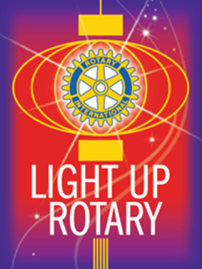
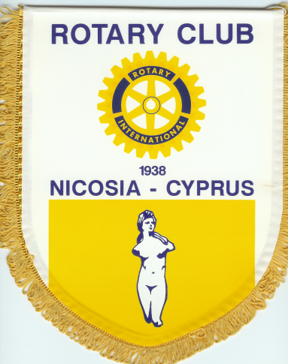
October – November 2014

2nd October : General Assembly in presence of Mr. Glafkos Georghiou, Assistant governor for our Club

7th October : President Pary at Mr. Robert Stambouli’s residence. That night, we raised 975 Euros for the Alzheimer cause.

16th October : Regular meeting. The Club decided to sponsor 10 Rotaractors for their 1st Rotaract Academy.

23rd October : Checks for 4000 Euros each handed to the President of the Cyprus Association of Cancer Patients and Friends and to the Manager of the Charity Center “Angaliazo”. Income from the 12th September Rising Opera Stas in Pallas Theater.

31st October : We joined RC Nicosia-Aspelia and RC Nicosia-Lefkothea for a lunch. The Minister of Finances, Mr. Harris Georgiades, spoke about the economic situation of the island in a very positive way.

1 – 2 November : Rotary Cyprus General Assemblt, Argos

Very interesting training on several subjects and approval of the budget. Extra funds 66000 Euros were declared available from the Cyprus Conference of 2013. The funds are earmarked for a big project to do for all the Rotary clubs of Cyprus.

3rd November : The Governor of Disctrict 2452, Mr. Khalil Alsharif meets the members of our board during his visit to Cyprus. We received congratulations for having performed in 4 of 6 fields of Rotary International.

3rd November : Induction of new members, Maria and Xenis Xenides

5th November : The Governor visits the Kaimakli Alzheimer Center

5th November : Rotaract meeting with the Governor and exchanging banners. The Governor was quite impressed by the commitment of all those youn Rotaractors.

13th November : Speaker Professor Dr. Andreas Theophanous. Subject “The Cyprus economic crisis and the way out”. Obviously less optimistic view of the Cyprus economy.

14th November : 25th Birthday of Rotaract Nicosia, an evening with a lot of fun and youth where 2 new members were pinned

27th November : We invited Mrs. Chrystalla Georghadji, Governor of the Central Bank of Cyprus. We arranged to be a joint meeting with RC Nicosia-Aspelia and RC Nicosia-Lefkothea. The Governor gave an optimistic view for next year banking sector. Questions were numerous.

6th December : Christmas Carols at Pallas Theater with Katie Economidou and Leandros Sitarou Chorus . A very successful evening with wine offered by Rotarian Andreas Psaras from the famous Makkas Winery.

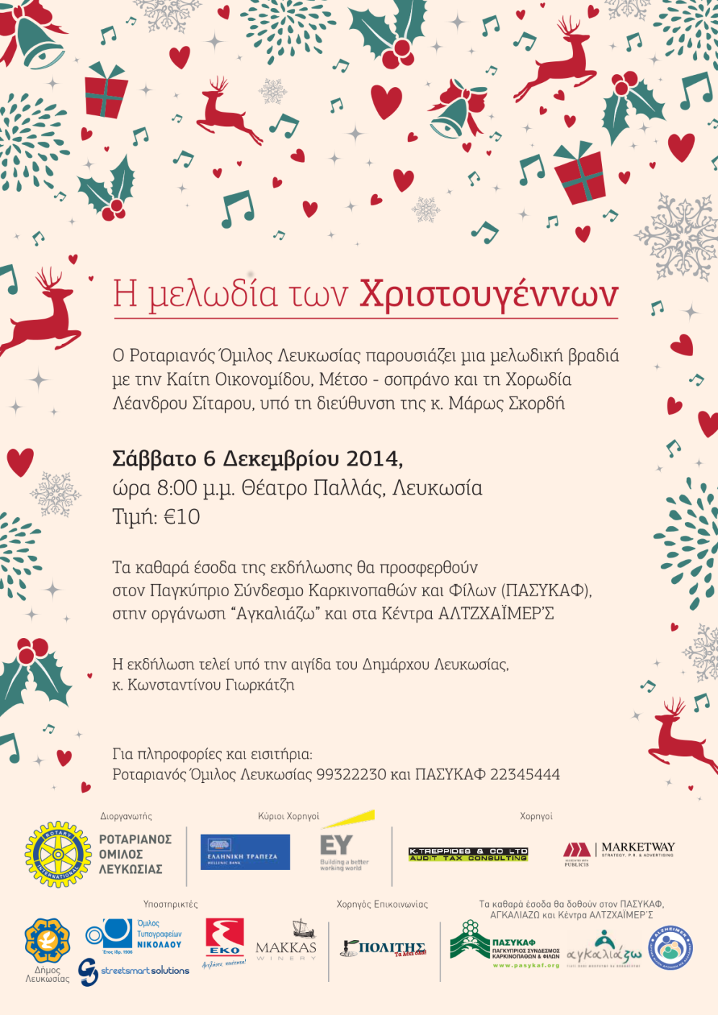

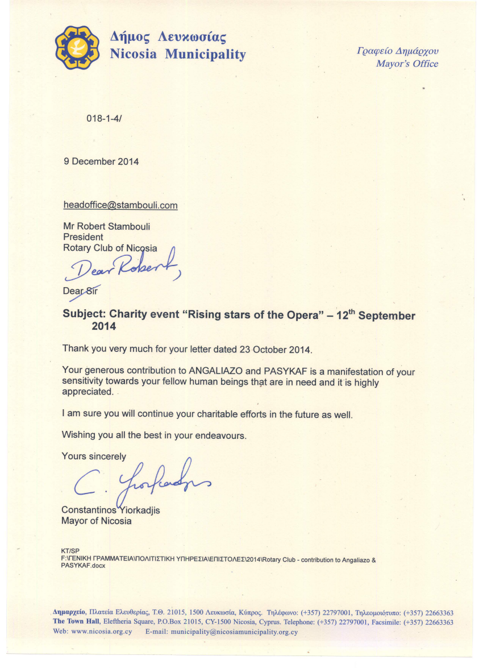

18th December :

Very successful full house Christmas lunch with the choral “Volunteets of Love”

19th December : Maria Christopoulou Christmas Open House – a nice fellowship evening which raised over 1000 Euros for the scholarship fund in honor of her father

23th December : Visit to Makarios Hospital with M. Christopoulou, group of teenagers and Father Christmas giving presents to over 30 children. The smile on the children faces was our best Christmas gift.

HAPPY NEW YEAR TO ALL!

LET’S MAKE 2015 AN UNFORGETTABLE ROTARY YEAR FOR OUR CLUB WITH 6 MORE MONTHS OF MY PRESIDENCY AND 6 MORE MONTHS OF DICKRAN OUZOUNIAN PRESIDENCY!

THANK YOU FOR YOUR COMMITMENT TO ROTARY

