


ΡΟΤΑΡΙΑΝΟΣ ΟΜΙΛΟΣ ΛΕΥΚΩΣΙΑΣ – ΑΣΠΕΛΙΑ
District 2450 Club 31029

______________________________________________________________________________________________

P.O. Box 16240, CY 2087, Acropolis, Cyprus
http://www.rotary-cyprus.org/nic-aspelia/

Rotary Club Nicosia-Aspelia Scholarship Fund Registered Charity no.: 13.36.002.04

CLUB BULLETIN No. 11 – Thursday November 1, 2012
Contents

- Rotary Awareness
- Agenda
- Minutes
- Photo Gallery
- Calendar
Weekly Message

On 24 October it was World Polio Day
You may learn more at the new site:
http://www.endpolio.org/


End Polio Now
Help Rotary meet the challenge

Rotary Foundation Future Vision

Pilot overview: The Rotary Foundation Future Vision Pilot is a three-year test of the new grant structure offered in the Foundation's Future Vision Plan. One hundred districts are participating in the pilot. Pilot districts will have a unique opportunity to help refine the new grant structure by providing input and receiving specialized Foundation support and service.

Grant structure
Pilot districts will work with Rotary Foundation District Grants and Rotary Foundation Global Grants for three years of the pilot. Download the terms and conditions for these grants. For more information, view the " Choosing a grant " interactive training module.
Rotary Foundation District Grants
District grants are block grants made to districts for up to 50 percent of their District Designated Fund (DDF). District grants offer the flexibility to respond quickly to immediate needs or to plan projects with clubs locally or in other countries.

Rotary Foundation Global Grants
Global grants support large international projects with sustainable, high-impact outcomes in the six areas of focus that correspond to the Foundation's mission.

Areas of focus
- Peace and conflict prevention/resolution
2. Disease prevention and treatment
3. Water and sanitation
4. Maternal and child health
5. Basic education and literacy
6. Economic and community development

Visit the " Future Vision Overview " interactive training module for more information

AGENDA OF THE NEXT MEETING – NOVEMBER 1, 2012
19.15 Arrivals - Drinks
- Apologies for absence
- Introduction of visitors
- President’s announcements
- Birthdays
20.25 Raffle
20.30 Close

MINUTES OF THE MEETING OCTOBER 25, 2012

Acting Sergeant at Arms: Nazo Davidian.

Grace: The grace was read by Nazo Davidian.
Apologies for Absence: There were no apologies.
Rotarian Visitors: PPDG George Papaleontiou (speaker), P Peter Georgiades, Bob Riddle (Rotary Club Caterham, England)
Guests: Julie Riddle, Carol Georgiades, Theodora Vrionides
Attendance: Courtesy of Rtn Amal el Khoury: Meeting average: 31% (15 members attended) Yearly average: 55%

Communication of apologies: You may forward your apologies at the e-mail address of Sec Pia Ceder. Communication of make ups: You may forward your make ups at the e-mail address of Rtn Amal el Khoury

President’s Announcements

President Eleni welcomed our guests and speaker.

October – vocational month
October is vocational month and Aspelia initiated this month with the vocational project, the Entrepreneurship seminar, followed by the cultural visit at the exhibition in the Bank of Cyprus Cultural Foundation and during today’s meeting we will learn more about the Rotary Foundation Future Vision Plan.

Cyprus on top of the RGH World
The rewarding and happy message that we all have received in an e-mail from DDG Fantinos Hadjimitsis was read. As an appreciation by RGHF the map of Cyprus is included on the main page of RGHF´s webpage. The map is referring to the first world records of Cyprus Rotary.

District Conference
Aspelia targets 100% registration;

Magazine
P Eleni presented the Magazine issued by 96 Rotary Innerwheel Distric where PP Nina Sadek is Chairman. Congratulations for her efforts.

Forthcoming events

Tickets for the Katerina Mina Concert are for sale. The event is a promising and enjoyable night with unforgettable Italian and Greek melodies. Please try to attend and bring along your family and as many friends and business associates as possible.

On the dinner meeting the 8 November Julia Papageorghiou of JPP marketing will speak about the very interesting subject The Social Media that has penetrated in our every day and professional life.

31 October is Board meeting.

1 December it the Rotary Foundation Seminar in Limassol. An important seminar as it concerns Rotary future vision and what changes will apply as from July 1, 2013.

November 30-December 2: Peace Forum in Berlin. President Tanaka personally invites all Rotarians, community leaders and New Generation Program participants to attend.


Rotary Global Peace Forums
Register to

Speaker

P Eleni welcomed PPDG George Papaleontiou who gave us a presentation of the Rotary Foundation Future Vision Plan. He clarified and explained the new simplified Rotary Foundation Grant system.

Check out the Terms and Conditions for Rotary Foundation District Grants and Global Grants, which become effective on 1 July, the full launch of the new grant model.

The presentation and clarification was very much appreciated, also by our Rotarian guests from England. Several questions and discussions followed.

Birthdays and Raffle winner

The birthday of PP Caterina Kalavas was celebrated.

Treasurer Walter Bopp was the lucky raffle winner.

______________________________________________________________

Meeting concluded at 20.30 pm.

PHOTO GALLERY

The Cultural visit at the Exhibition of the Bank of Cyprus Cultural Foundation:

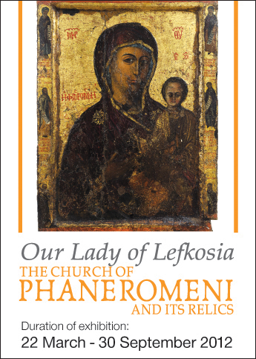

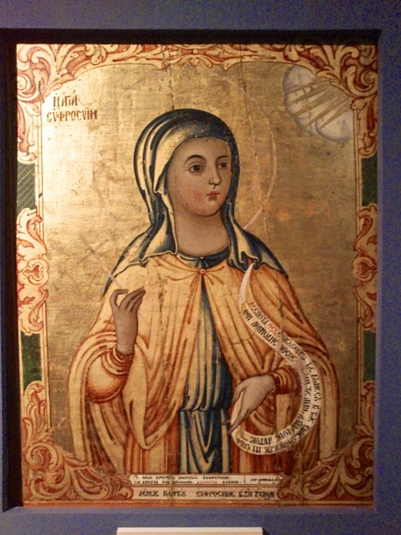

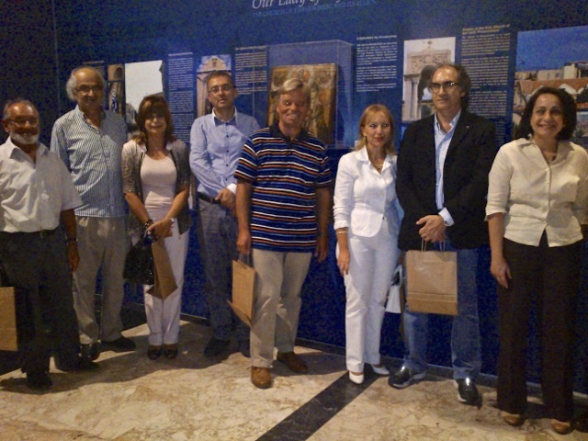

Meeting 25 October 2012:

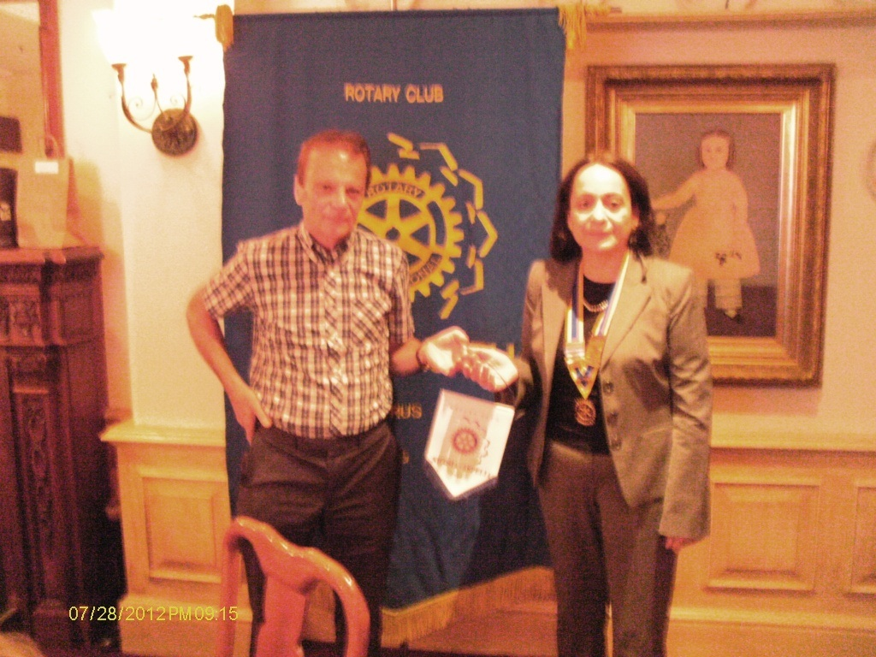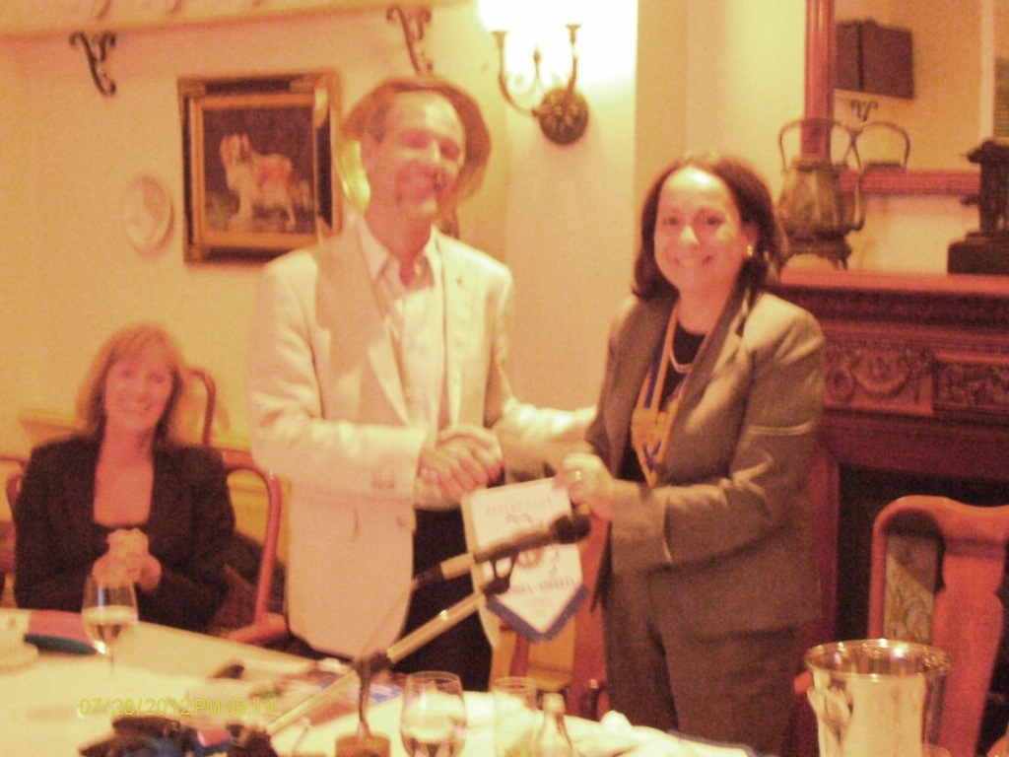
P Eleni thanks PPDG George Papaleontiou for his presentation

President Peter Georgiades from RC Caterham UK

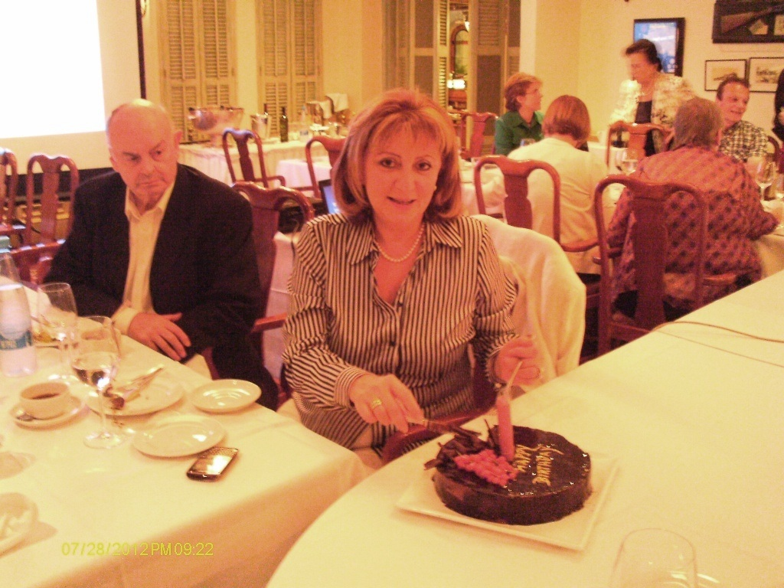
PP Caterina Kalava’s birthday cake

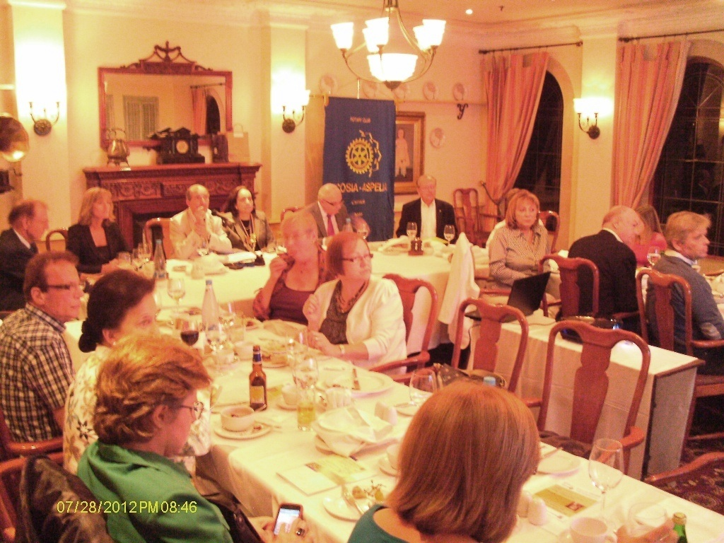

ASPELIA CALENDAR, COMING EVENTS

Meetings at Hilton Hotel Nicosia Thursdays at 19.30

october
(vocational service month)
3 Wednesday | Board Meeting 18.00
4 Thursday | Regular meeting, drinks 19.30
6 Saturday | Entrepreneurship Vocational Projet
11 Thursday | Regular Meeting, dinner 19.30. SPEAKER Mr Constantinos Yiokadjis, Mayor of Nicosia
13 Saturday | District Conference update at Elias Hotel Limassol
18 Thursday | Regular Meeting, Cancelled
19 Friday | Exhibition Tour at the Bank of Cyprus Cultural Foundation and Fellowship fundraising dinner 19:30
25 Thursday | Regular Meeting, dinner 19.30. SPEAKER PDDG George Papaleontiou: Rotary Leadership
31 October | Board Meeting 18.00

november
(Rotary foundation month)
1 Thursday | Regular Meeting, drinks 19.30
8 Thursday | Regular Meeting, dinner 19.30. Speaker Julia Papageorghiou:
12 Monday | Katerina Mina Concert Fundraising Event for the Aspelia Scholarships
15 Thursday | Regular Meeting, drinks 19.30
22 Thursday | Rotary Meeting, dinner 19.30
29 Thursday | Regular Meeting, drinks 19.30. DDG Fantinos Hadjimitsis visits.
30 November – 2 December | Peace Forum in Berlin, Germany; Peace without border

DECEMBER
(FAMILY month)
1 December | Rotary Foundation Seminar, Elias Beach, Limassol
5 Wednesday | Board Meeting 18.00
6 Thursday | Club Assembly, dinner 19.30
13 Thursday | Regular Meeting. Cancelled
14 Friday | Christmas lunch at Cleopatra Hotel
20 Thursday | Regular Meeting, drinks 19.30

The programme is subject to changes

Pia Ceder
Secretary
Rotary Club Nicosia - Aspelia

