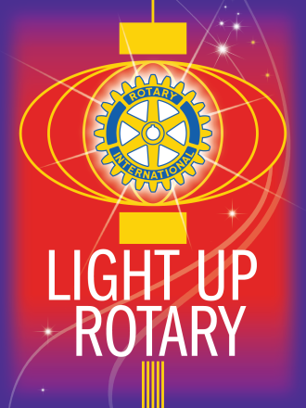

**WEEKLY NEWSLETTER**

**District 2452 – Club 13371 – Year 2014/2015**

**President: Vasilis Hadjivasiliou**

|  |  |
| --- | --- |
| **OUR MEETING IN SUMMARY** | |
| Date | 9th July 2014 |
| Attendance | 55% |
| Birthdays and Donations |  |
| Grace by: |  |
| Agenda next meeting | Speech by the Secretary General of the Cyprus Shipping Chamber, Thomas Kazakos |
| Apologies |  |
| Raffle |  |
| Guests | Petros Hadjivasiliou, Christos Patsalides, Christos Christou |

Our weekly meeting was in the form of a Fellowship Meeting on the occasion of the Semi Finals of the FIFA World Championship at Chester’s n Limassol. The match between Argentina and Holland ended 0:0 after regular time, and 2:4 after penalty shootout (Argentina won).

It was a nice meeting with everybody enjoying the evening. The net proceeds from the evening were EUR 80.00 for the Club.

**REMINDER:**

Pictures have been uploaded to our Facebook site <https://www.facebook.com/RotaryClubofLimassol>

Please visit the site and ‘like’ it!



