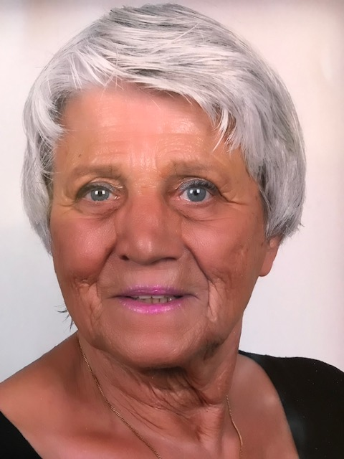

Curriculum Vitae

Name: Anja A.F. van Raam
Address: Bellapais
Northern Cyprus
Mobile: 06-462868888
Email: anja@ag46.nl
Birth date: 10-03-1946
Nationality: Netherlands

Social functions:
- President of the Dutch Association of Swimming Teachers (1979 – 1987)
- Chairman SamenLoop for Hope department Almere (Dutch Cancer Organization) (2011 – 2017)
- Chairman of the Committee on Logistics Confluence for Hope Department Almere (Dutch Cancer Organization) (2017 - 2019)
- President Rotary Club Kyrenia Cosmopolitan (2020-2021)

Motivation:

In the coming years I would like to use my abilities and professional achievements to contribute as a board member and trainer/teacher for (board) members of rc Kyrenia Cosmopolitan.

Personal attributes:
Drive, innovative, responsible, enthusiastic, stimulating, clarity, commitment, reliability, tenacity, guest orientation, stress resistance, care, inquisitiveness and sporty. Communicative in words and writings.

Personal skills:
Broad training in combination with practical and proven experience at University/HBO level.
Situational Leadership. Systematic work. Experience with/in service. Solution-oriented.
Crisis management. Familiar with laws and regulations. Open to new developments. Like to enter new paths. Market- and initiative-oriented. An eye for teamwork and eye and ear for signals from the shop floor. Experience in negotiations trajected. Decision-making based on knowledge and arguments. Resolutely in position. Contact-oriented. Knowledge/experience with various management reports and management systems

Courses followed and relevant courses

* Hbo-study Therapist Integral Body Massage (1 year) 2010 – 2011

* Talent Development Project College (TOP and TOA Academy) 2004 – 2009

* Various internal training courses such as hot-stone, pulses, wellness
massage, foot reflex and aqua-balancing 2004 – 2006

* Certified Trainer Manager of a.o. Train the Trainer
Core qualities and the Core Quadrant 2001 – 2003

* Train-the-trainer training as a franchisetrainer
(3 months full-time) (Interselling Training B.V.) 2001

* Professional Interim-Management (Nijenrode University) 2000 – 2001

* Professionalisation training Interim-Managers (University of
Nijenrode) 2001 –2002

* Financial Management (Bureau Kees Horden e.g.) 2001

* Training Pitfalls in The Practice of the Interim-Manager
(Leeuwendaal Advies b.v.) 2000

* Manager and Assistant Manager Swimming Pools (ENVOZ) 1975 – 1979

* Higher Management (ISW) 1978

* Resource Management (ISW) 1976

* Course Recreation Swimming Leader (KNZB) 1976
* ABO diploma (NSF) 1974
* Degree Sports Massage (Gem. Amsterdam) 1965

* Degree Sports instructor (Gem. Amsterdam) (1962 – 1966)
* Degree KNBRD Rescue Brigade 1965
* Degree Swimming Teacher (KNZB) 1964
* High School for Retail 1958 – 1962
* Primary School 1952 – 1958

Hobbies
- Read
- Classic music
- Swimming
- Skiing
- Skating
- Underwater sport (Master Scubadiver)

