President 2022-2023

PRESIDENT’S UPDATE September 2022

Dear Rotarians and Friends of RCKC

The month of September has been a busy and very productive month. Both board and members of RCKC working very hard to deliver planned activities and events for this month while at the same time preparing for our planned events and projects for the next few months ahead.

SEPTEMBER BASIC EDUCATION AND LITERACY MONTH

On the 2nd of September we delivered the first of our planned motivational training for the teachers of Guzelyurt Meslek Lisesi. The training was delivered by esteemed trainer Dr Bilge Azgin and feedback received from the evaluations were very encouraging. RCKC together with the headmaster of GML Mr Rustem Kal will be exploring the possibilities of organising a community assessment within the next couple of months in preparation to seek funding in supporting the school’s needs.

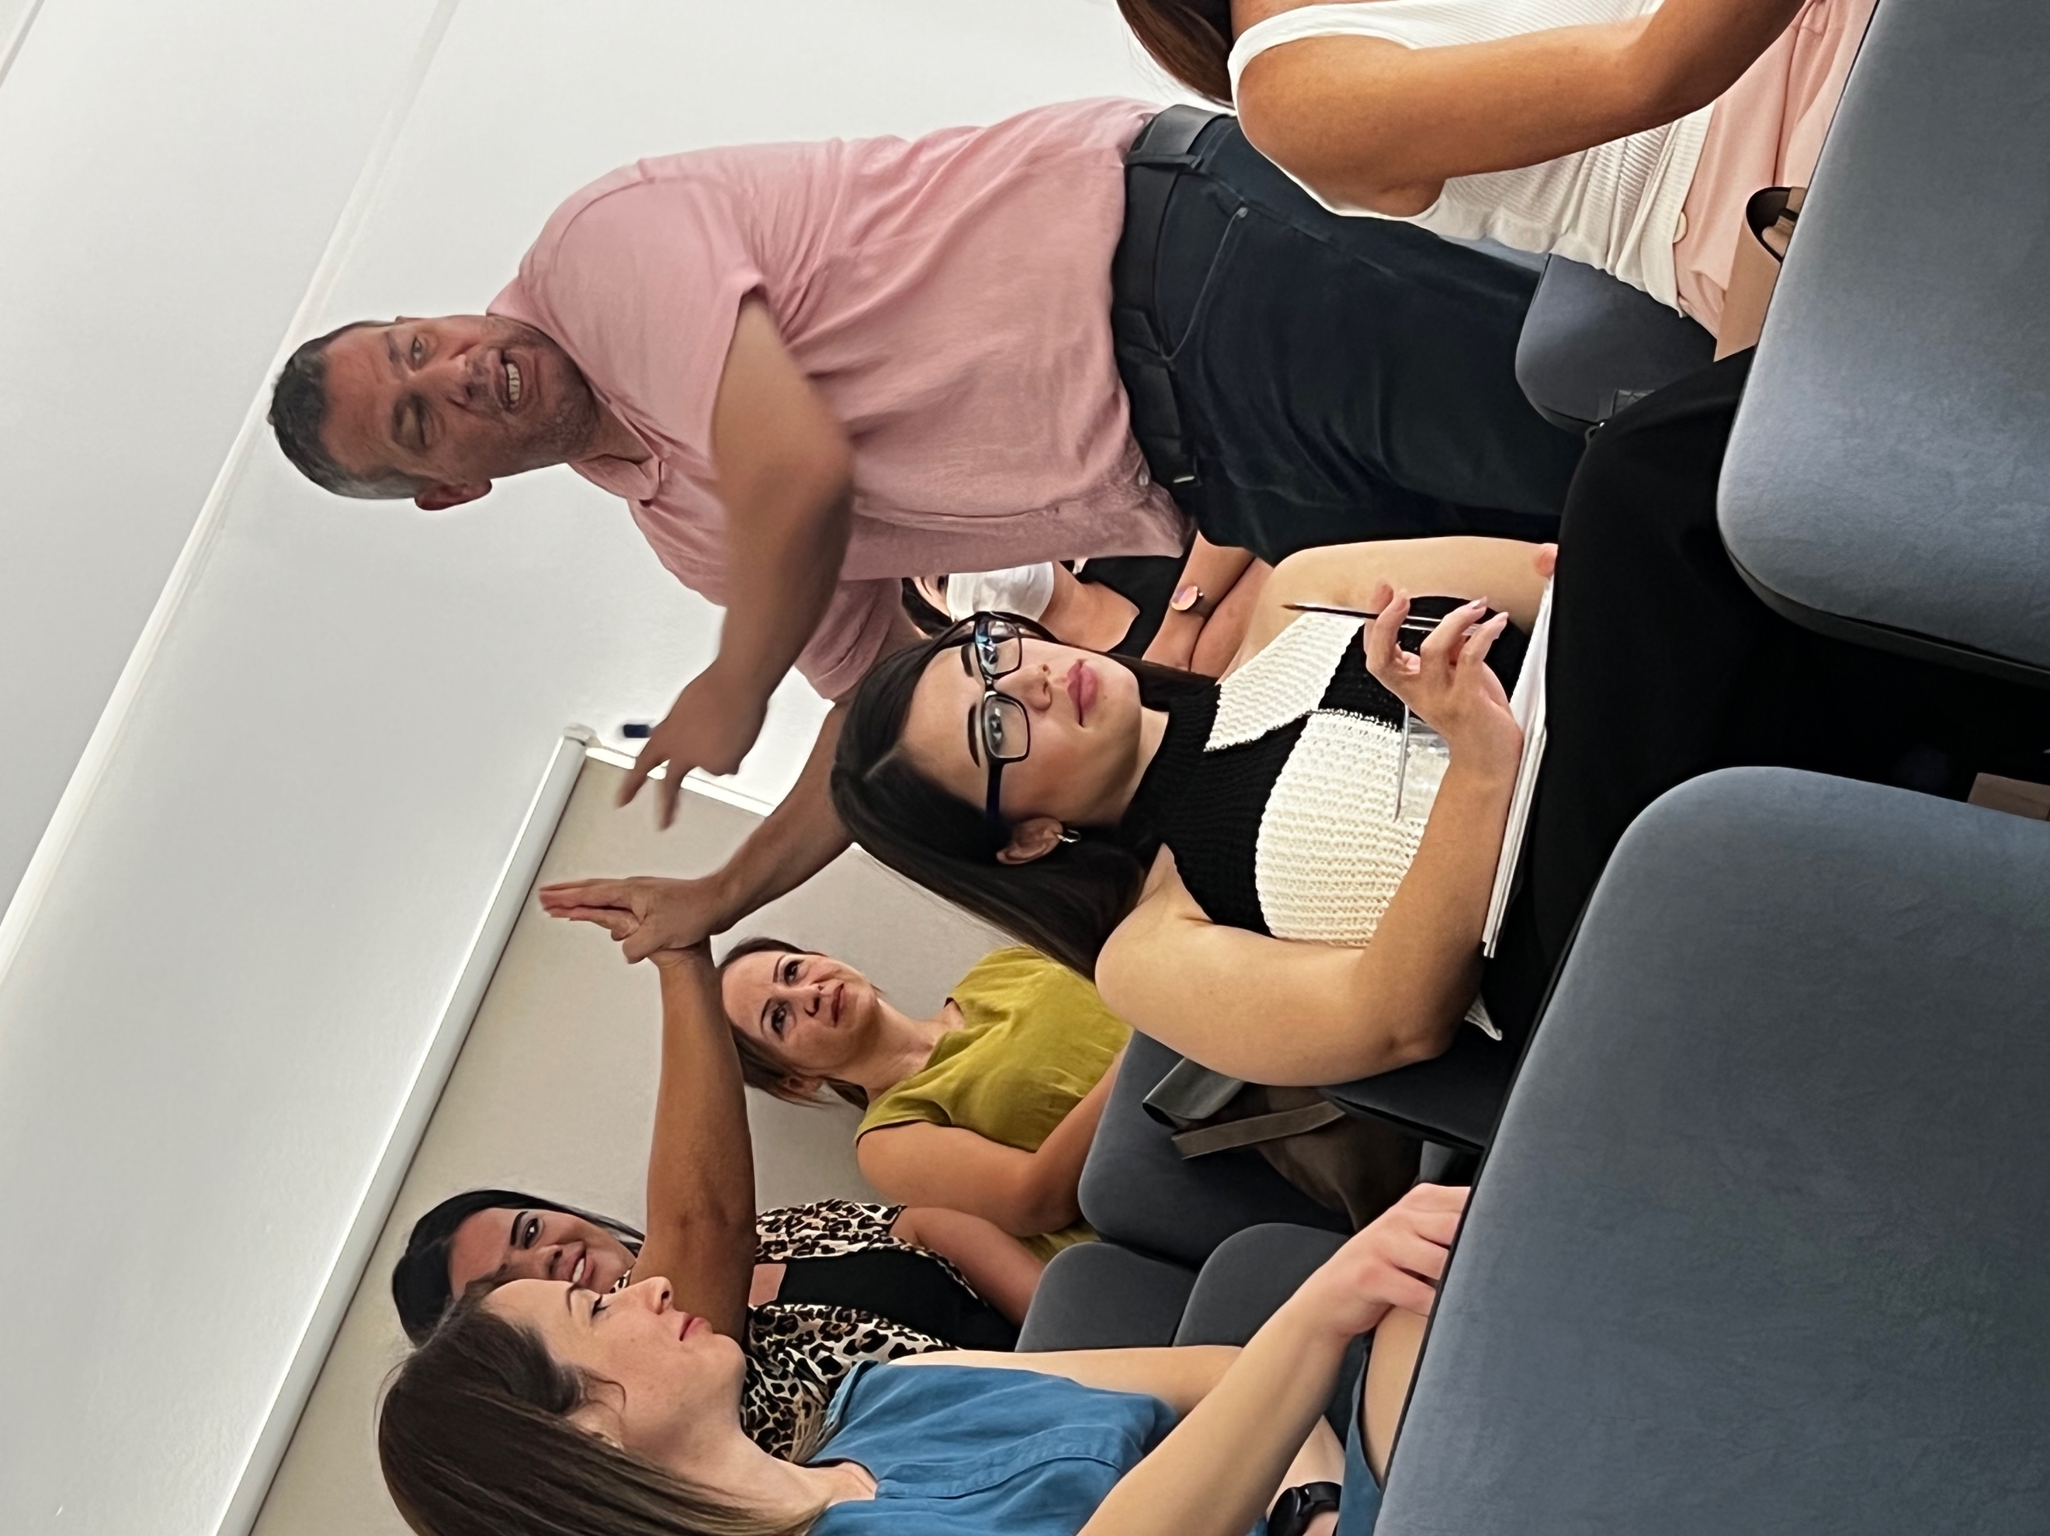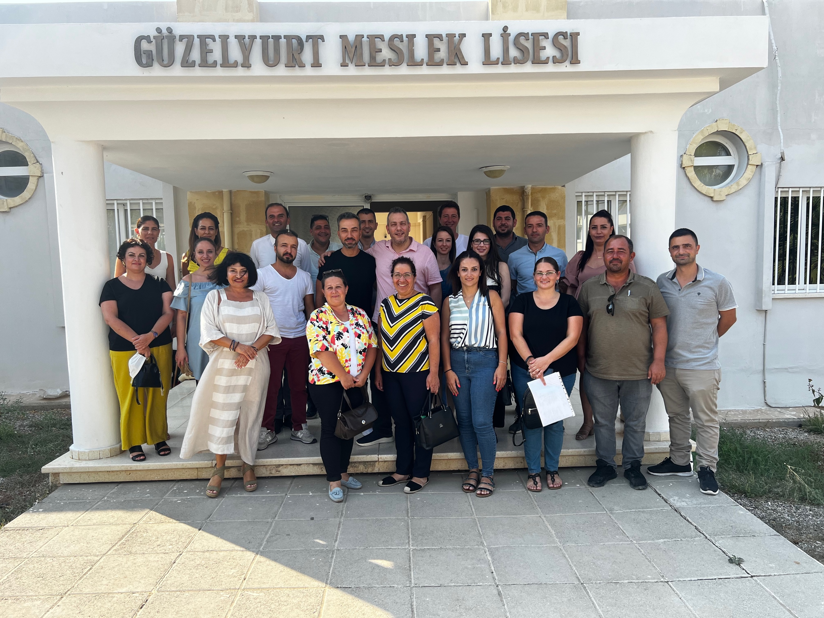

I have been approached by our CP Malcolm Mitcheson with the possibility of a very exciting project which will be sponsored by “The Friends of Karsiyaka Schoolchildren”, who have in their kitty, funding which was raised in the past for the benefit of raising the aspirations of the Karsiyaka schoolchildren. After consultation and approval of my board members I organised a meeting with the headmistress of the Karsiyaka Primary school and am working towards bringing this very exciting project to fruition. The project will involve:
- additional English lessons afterschool
- starting a Pollination Garden at the school
- providing educational material on the importance of Environment and Pollination.

I will elaborate more in the coming months as the projects outline and delivery becomes clearer.

FELLOWSHIP

RCKC also organised a fellowship meal at the Lords Palace Hotel. The board, members, potential members and Rotaracts attended this meal where we spent some leisurely time enjoying a delicious meal and enjoying each other’s company.

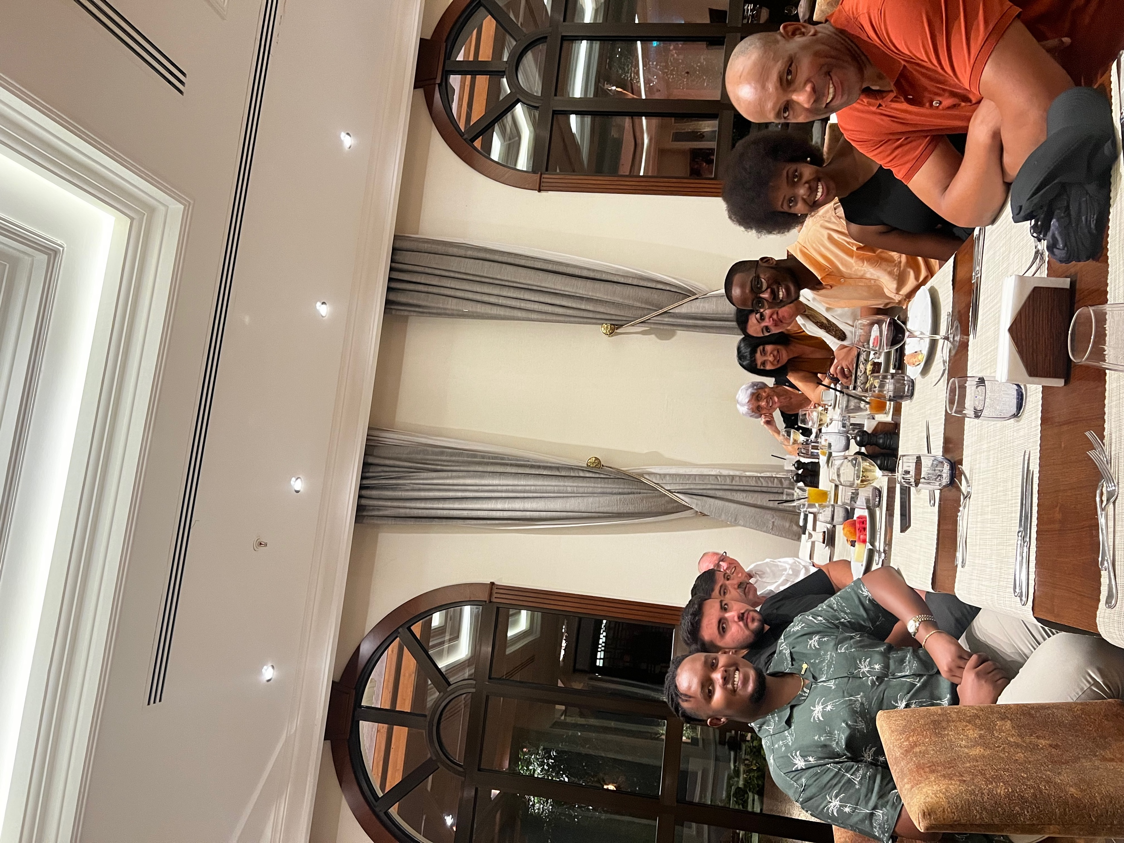

PAKISTAN DISASTER

Towards the end of August, the devastating floods in Pakistan caused many deaths and left thousands of families homeless. I contacted Tayyaba Gul from RC Islamabad to enquire what their immediate needs are and how we as RCKC can be of help.

I was informed that with the work Tayyaba Gul is doing with RC Nowshera they have provided the initial support of tents, food, clothing etc but are in need of female Hygiene kits. I informed our members and board of this and through the board members extreme generosity we quickly raised funds to provide Hygiene kits to 150 families.

The funds were sent to RC Nowshera, to distribute the Female Hygiene Kits by organising several Health Camps under the leadership of Tayyaba Gul

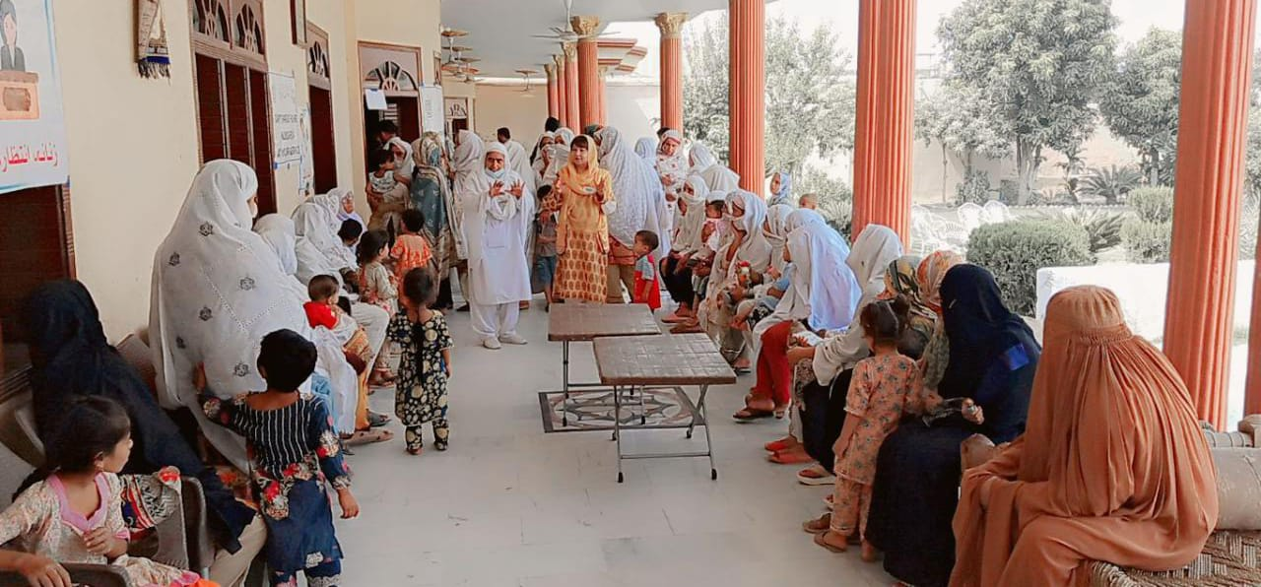

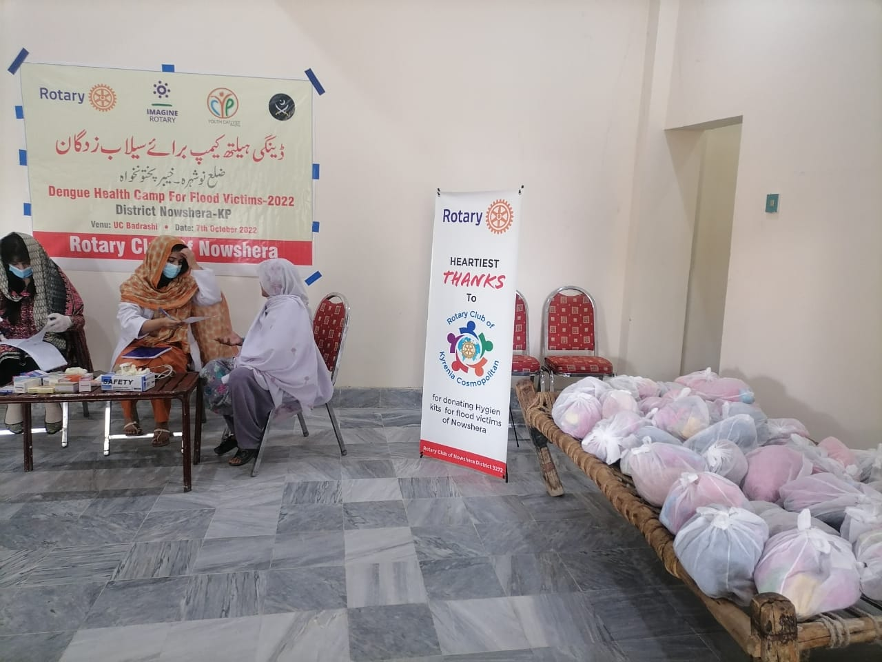

TRAINING FOR MEMBERS

As RCKC, we have also provided training to our board and members, this months main training was on ‘Flip Thinking” delivered by our PP Anja van Raam. ‘Flip Thinking” is aimed at helping us to look at issues from a different perspective which will assist in turning problems into opportunities. The training consisted of problem-solving activities which were both challenging and fun.

On the same day as our scheduled meeting/training event, was the birthday of one of our newer members Samson Balogun. Samson is from Nigeria and is here studying. We organised a surprise birthday cake for him and celebrated his birthday amongst his Rotarian Family in Cyprus.

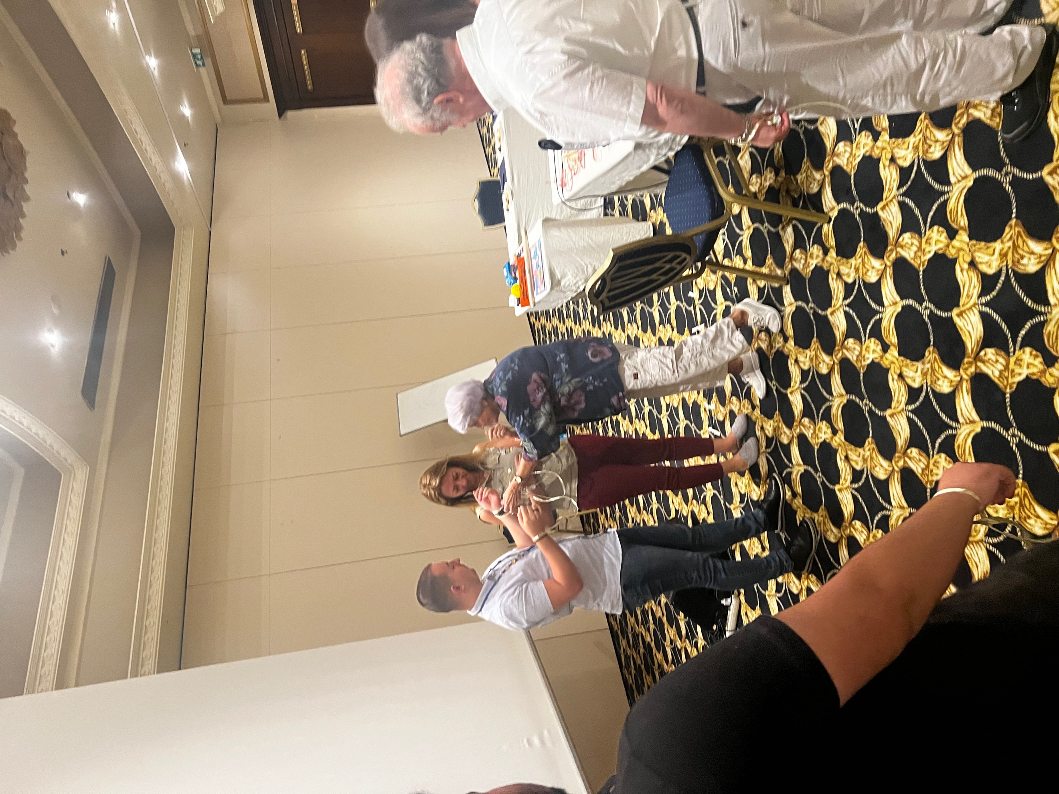

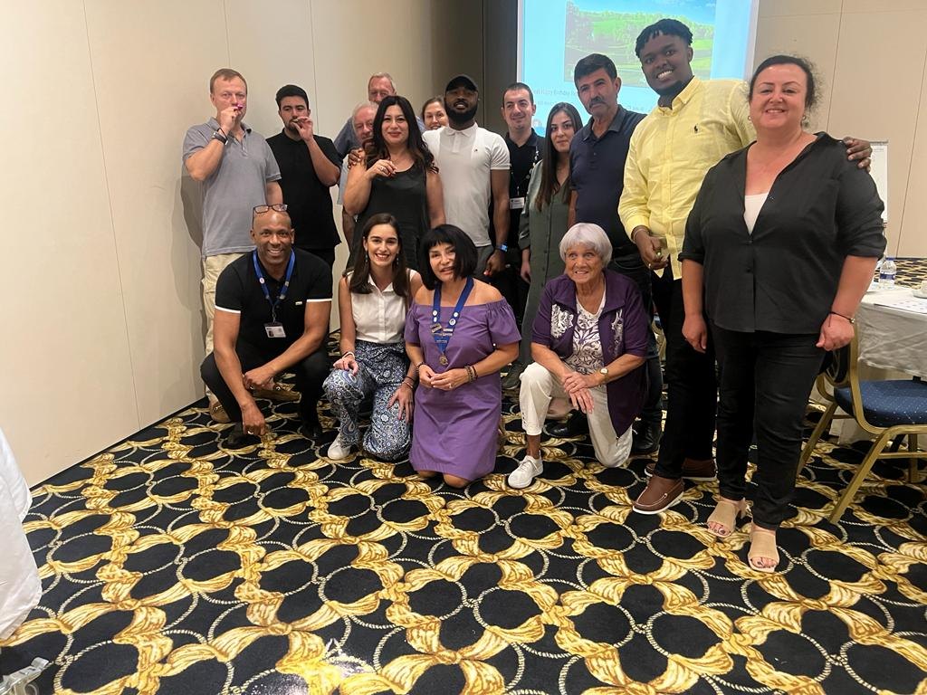

FUNDRAISING BARBECUE EVENT

We ended the month with a fundraising barbecue event held at Green Hill restaurant. Rotarians, Rotaracts, friends and family attended. we all enjoyed a feast with music and dancing.

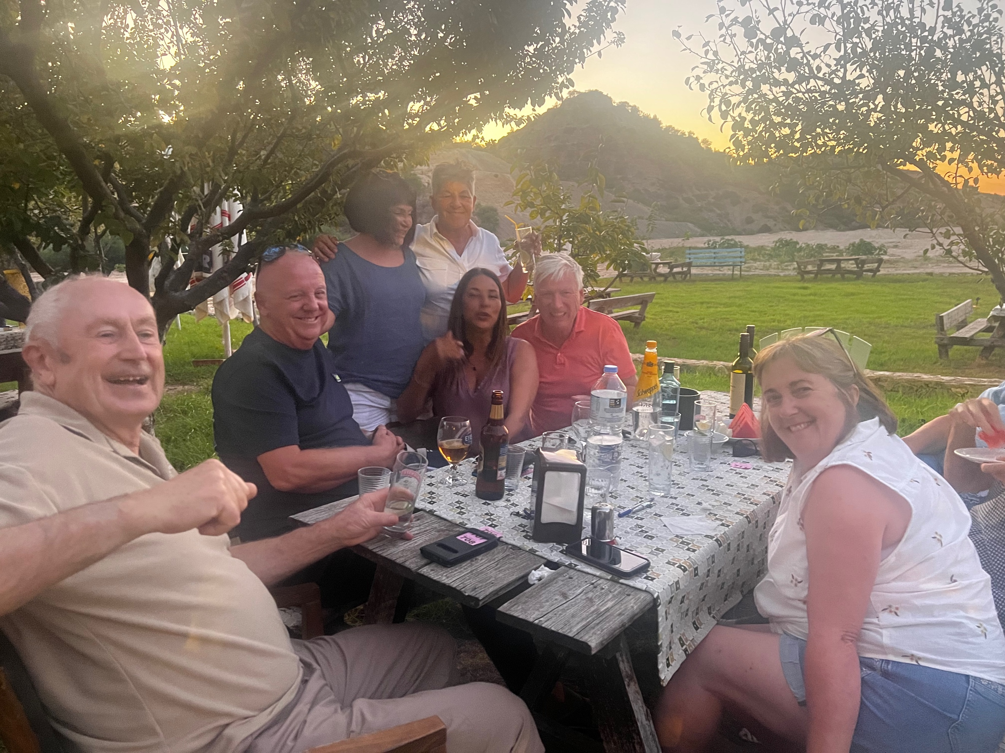

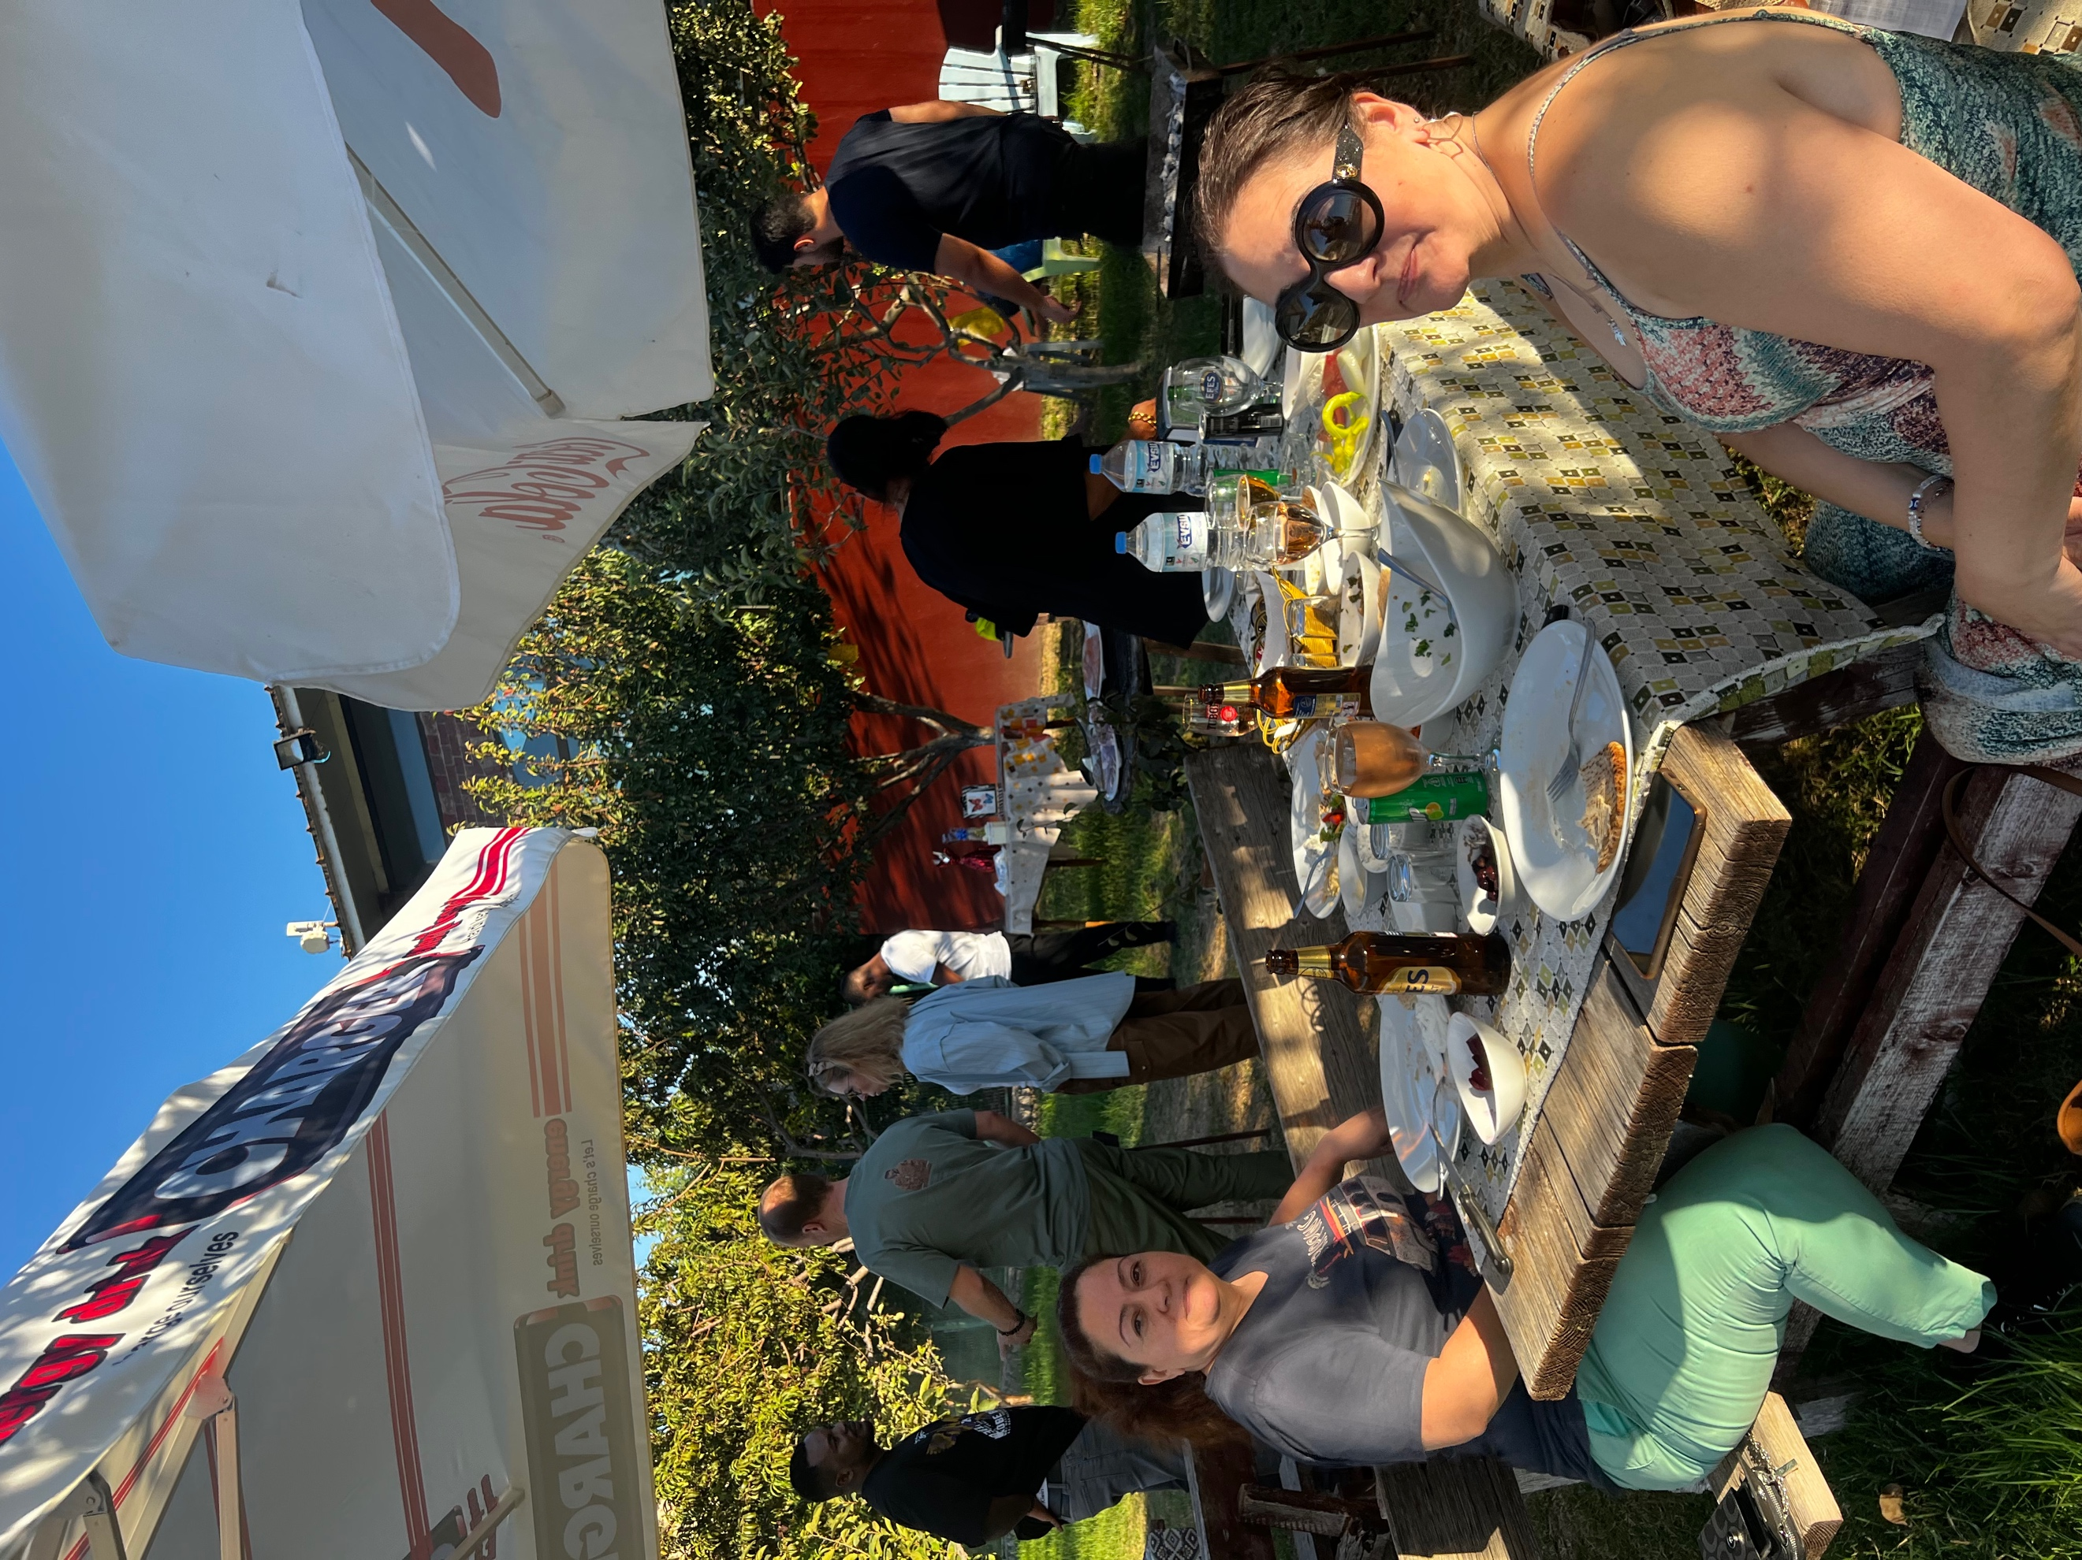

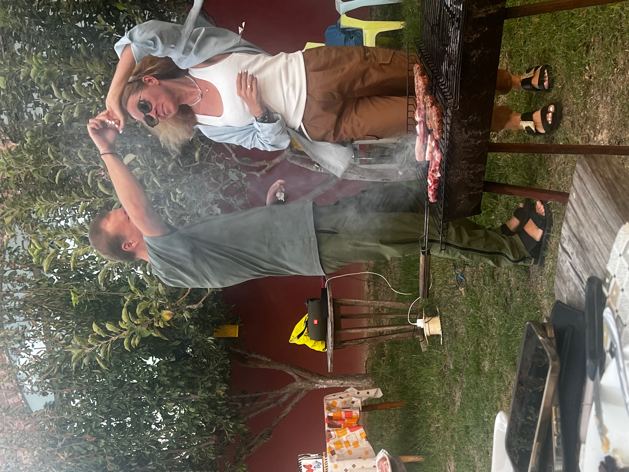
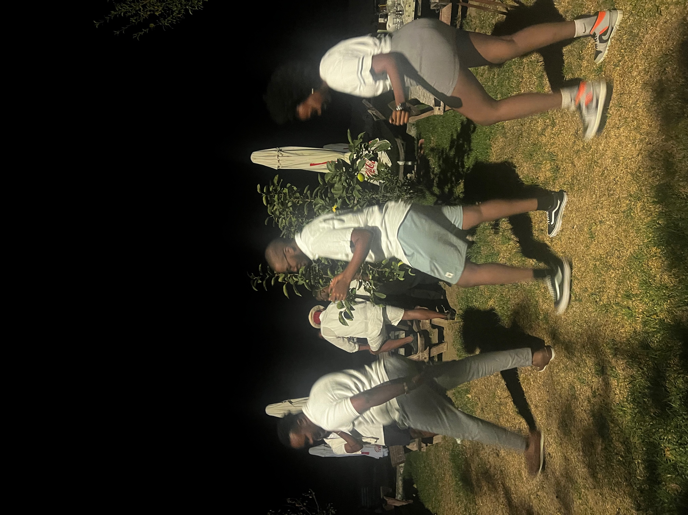

BOOKSIGNING EVENT

President and Past president of RCKC joined a book signing event organised by RC Liman at the Heaven restaurant. Members and board members of RC Sarayonu and RC St Hilarion were also present. The book was written by RC Liman member Dr Zihni Turkan on the history of Kyrenia Liman and Lefkosa Sarayonu. Following the book signing we all enjoyed a warm and friendly fellowship meal.

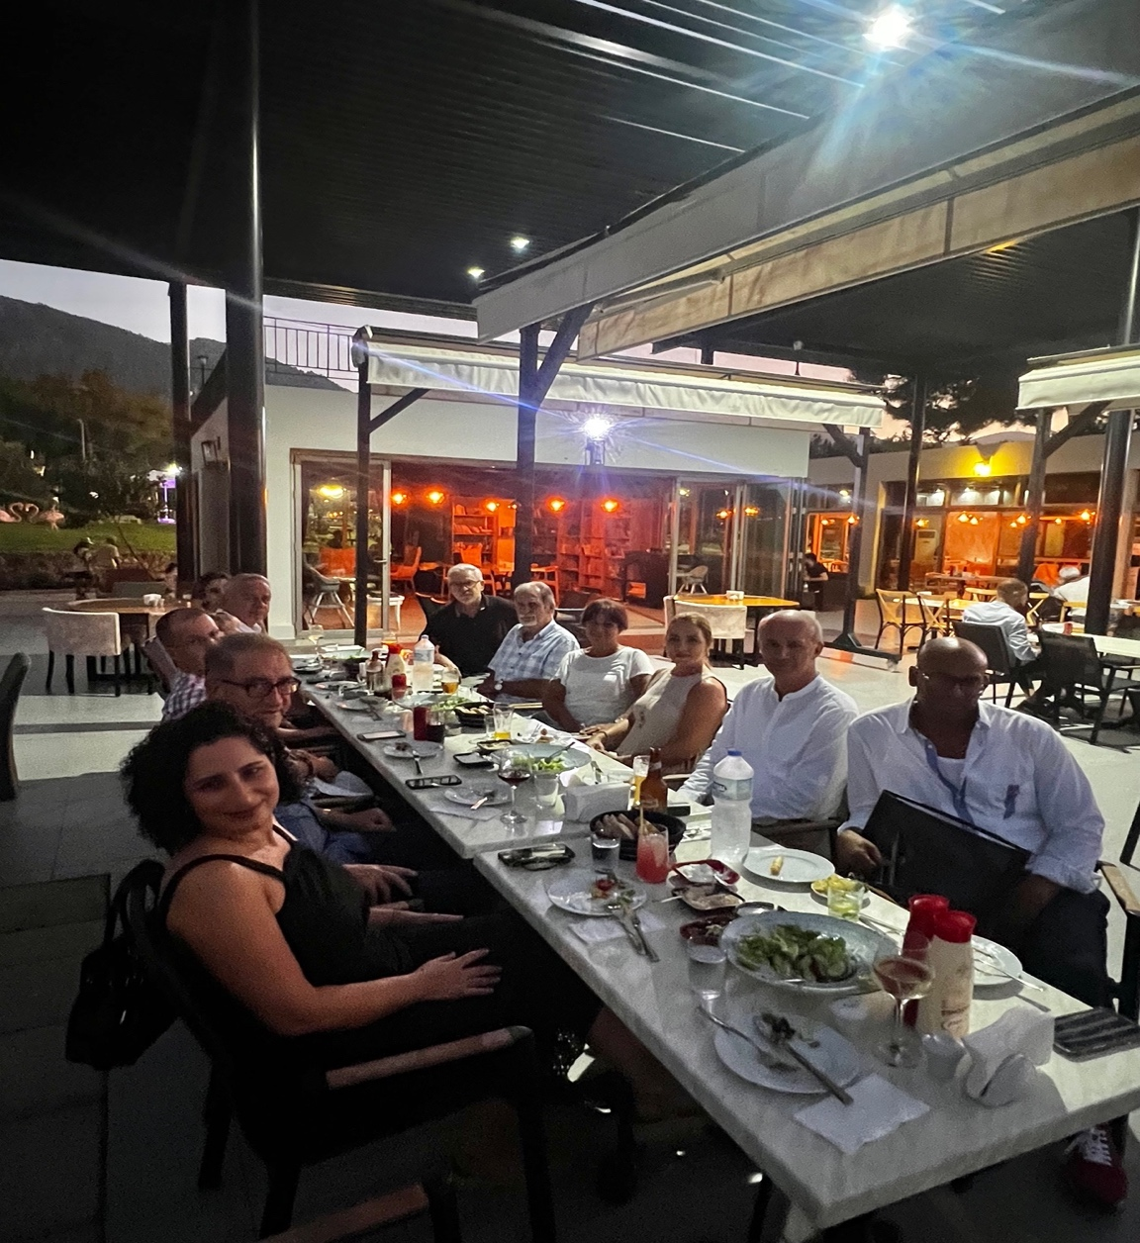

OTHER ROTARY WORK

In addition to all this, with support from some board members, I have been very busy preparing the list of requirements from our DG George Azar, which he requested is emailed to him one week prior to his scheduled visit of early October. Together with board members, we have also been preparing our presentation informing our DG of the work our club has done to date as well as our plans and aspirations for the year ahead, which will be delivered during our cheduled meeting with the DG. I have also been supporting AG Sertac Gumus in organising the Gala Dinner in honour of our DG due to take place following our presentations on 14th of October.

We have been continuing with the planning for the Polio event which we will be holding jointly with the four clubs in North Cyprus, scheduled for 22nd of October. Also continuing the planning for our annual Halloween event scheduled to take place on 29th of October.

As I said at the beginning of this report it has been a very busy month

I will end my September update with a quote I also used last month but I feel it is good continue being reminded.

“The distance between dreams and reality is called Action”

We are people of Action, who are committed in delivering a better future locally, nationally and internationally.

Thank you
Ayten Benoit
President of RC Kyrenia Cosmopolitan 2022-2023

