PRESIDENTS UPDATE OCTOBER 2022

Dear Rotarians and Friends of RCKC, October has been another extremely busy month with the planning and delivery of three major events, The District Governor George Azar’s visit, End Polio Now day and our annual Halloween event.

DISTRICT GOVERNOR GEORGE AZAR’S VISIT

As board members we were busy in collating the information requested by the DG and ensuring we submitted it to him via email one week prior to his visit. We then prepared a very comprehensive presentation, to present to DG George Azar, DDG Emilios Tannousis, Assistant Rotary Coordinator Zone 20 B Ahmad Husseini and Assistant Governors during our scheduled meeting with them, while at the same time planning the final arrangements for the Gala meal for the evening of our meetings which were all scheduled for October 14th.

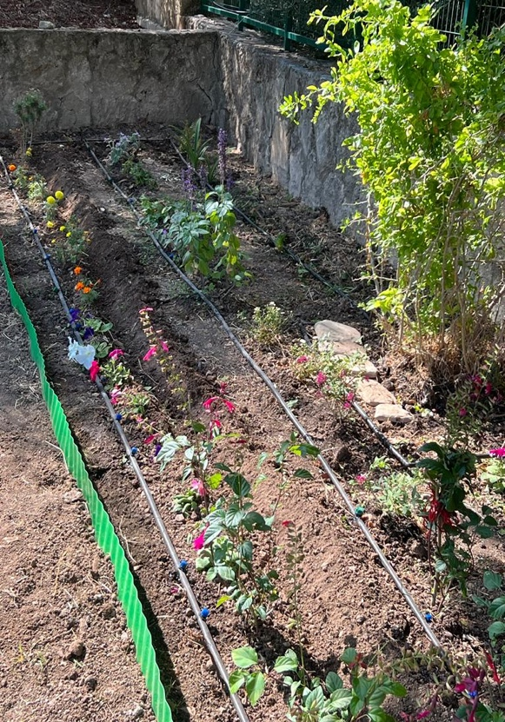
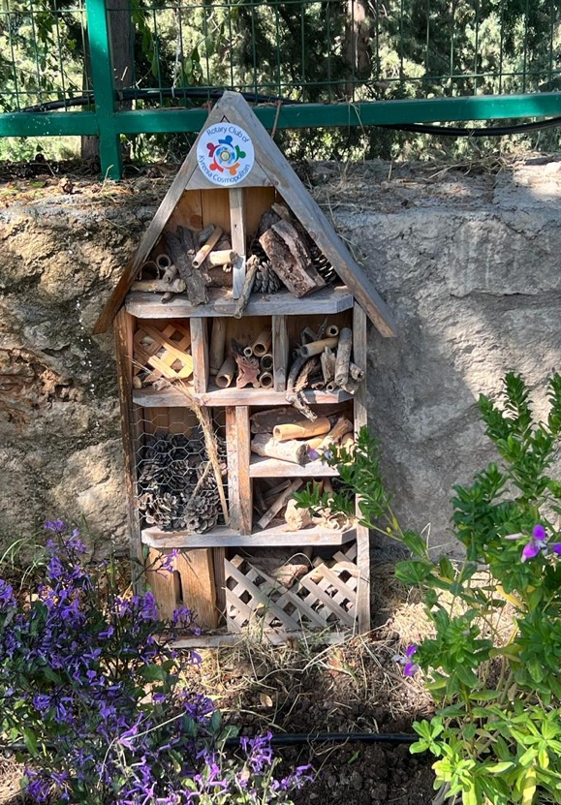
Although we knew our DG had a very busy schedule, we were very happy to be informed that he agreed to visit one of RCKC’s Pollination Projects at Belapais Pre-school, early in the morning of October the 14th. President and member from RC Liman and AG Sertaç Gümüş, were present in hosting and welcoming our DG, DDG and ARC. Following the visit to the project we all enjoyed lunch at the historic Belapais Monastery.

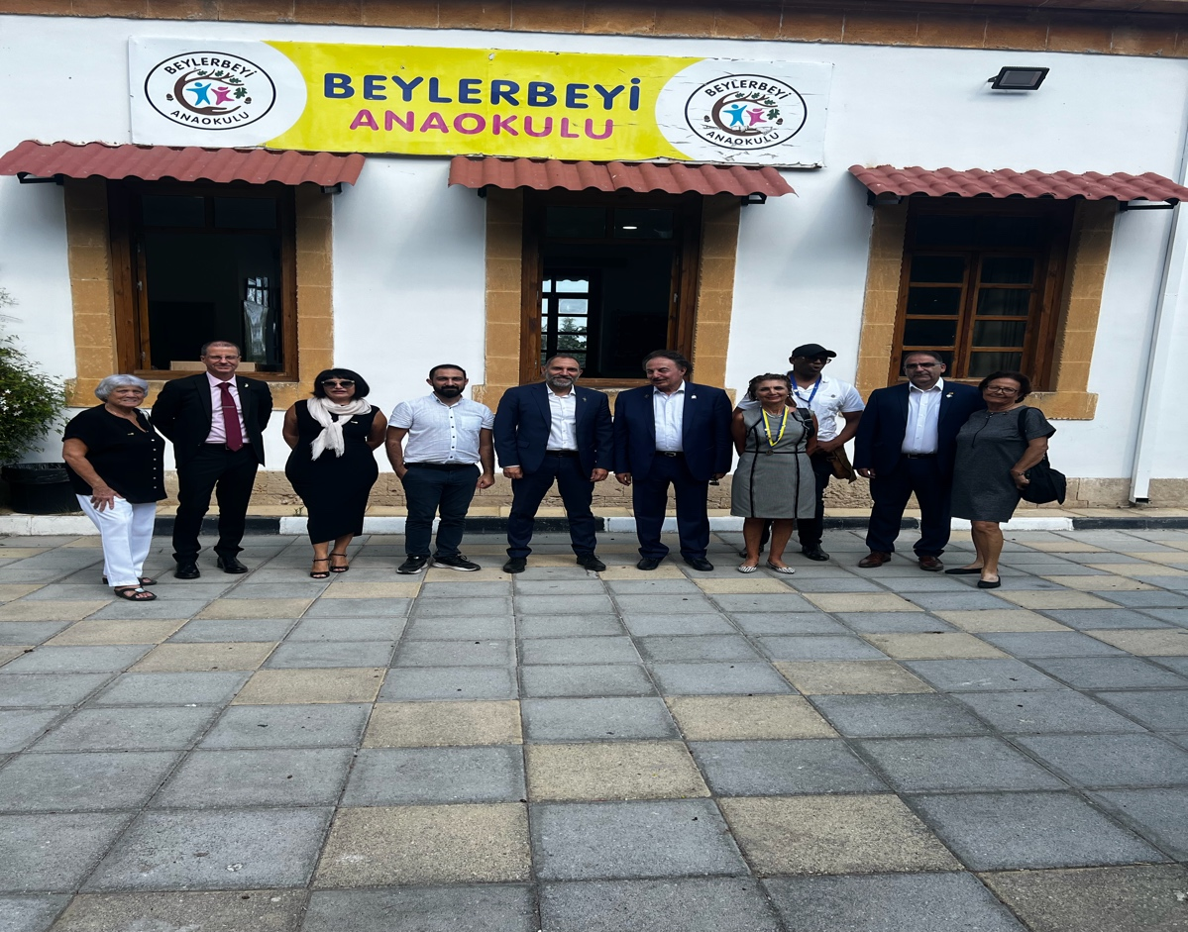
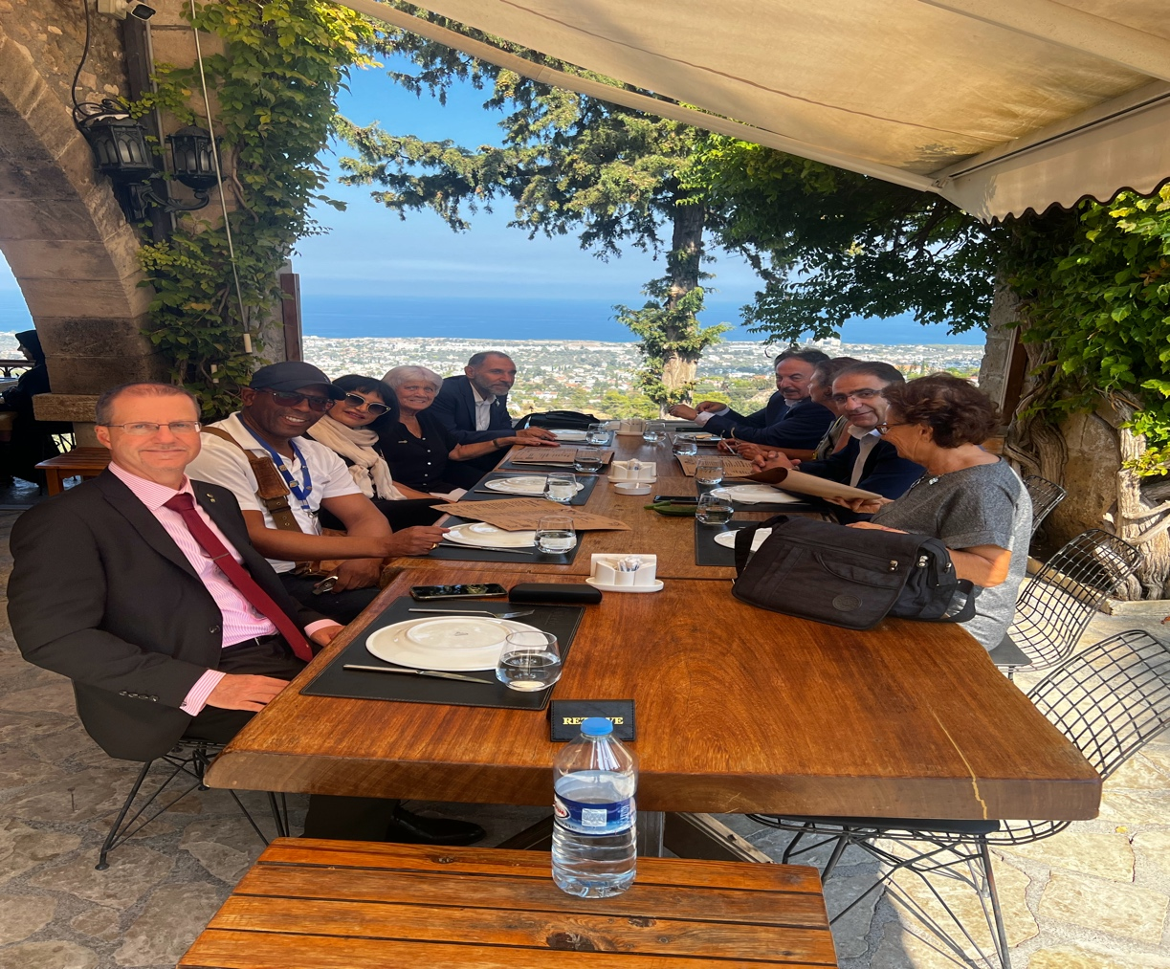

Ten members of our club, consisting of Board members, Members and Rotaracts all participated at the Presentation meeting with the DG, we believe we gave a very comprehensive presentation of our current work as well as our future vision as a club.

In the evening we had a Gala dinner where our Rotaract Mustafa read his Rotaract Pledge and got pinned by the DG and our Rotaract President Havva Ibrahimer was awarded a plaque in recognition of her hard work by PP Ben Benoit.
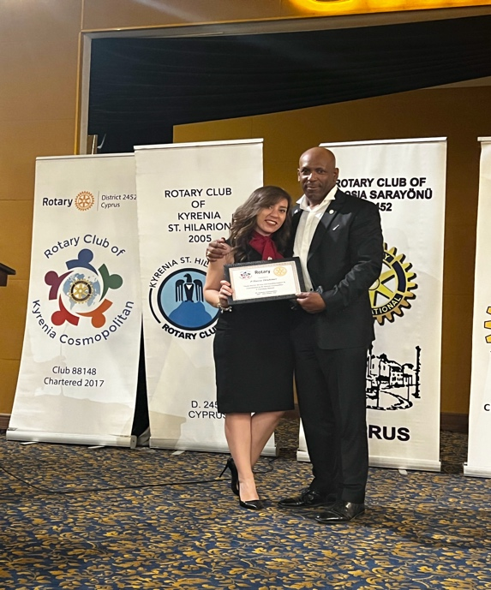
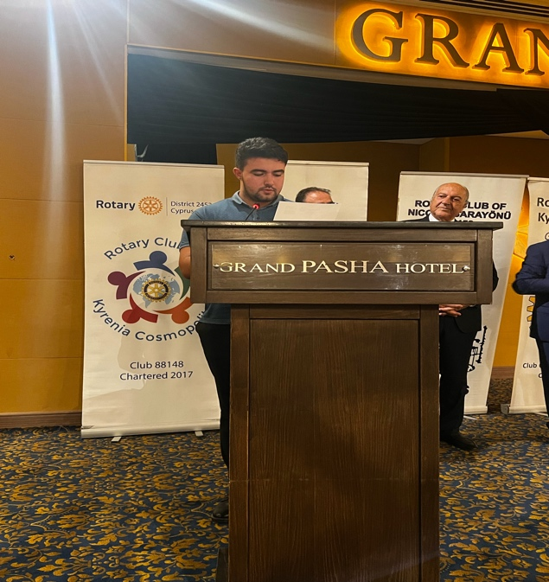
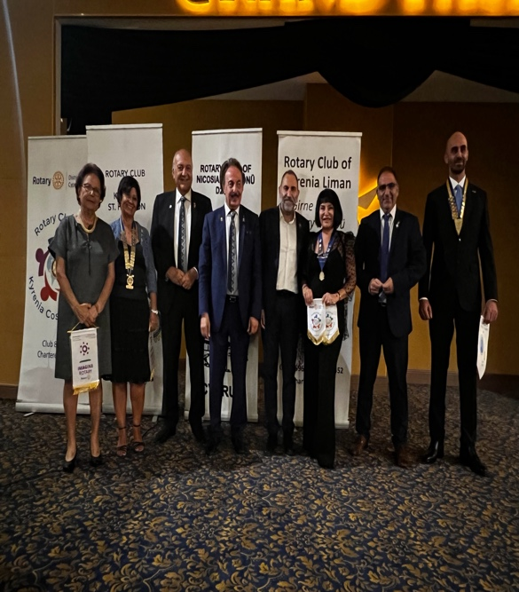
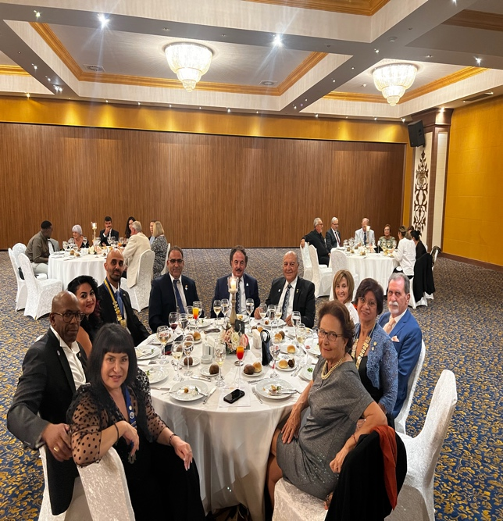

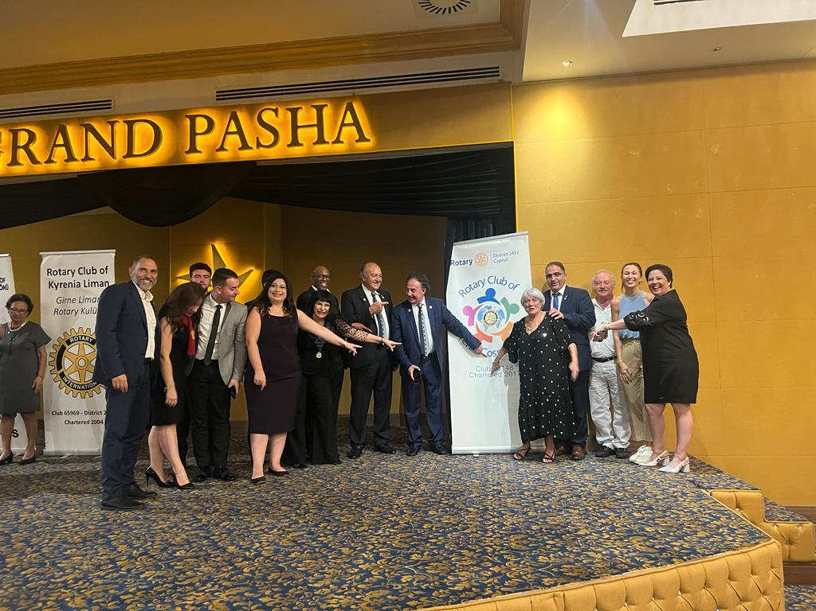

END POLIO NOW

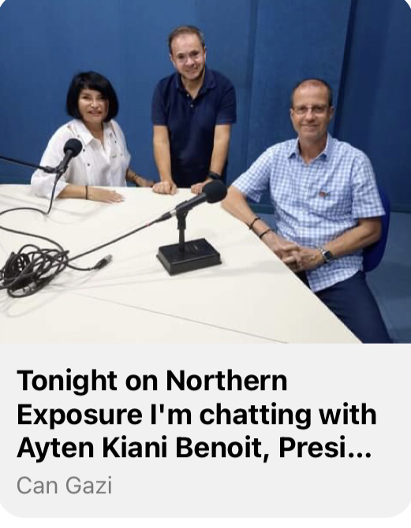
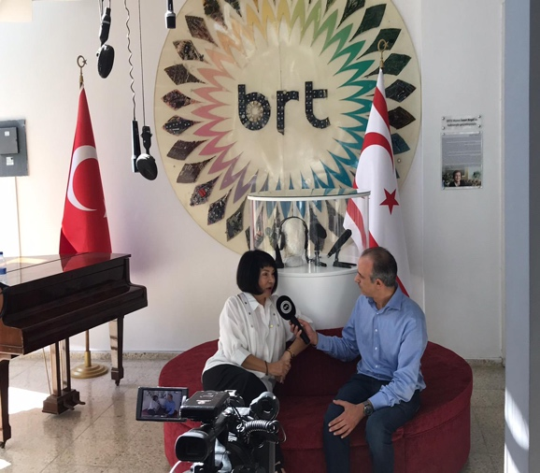
In the lead up to the joint ‘End Polio Now’ event of four clubs in the North of the Island we were busy promoting Polio awareness through all forms of media. As part of the promotion AG Sertaç Gümüş and myself took part in a radio followed by television interview in our national broadcast Bayrak Radio and Television.

We held out joint polio event on 22nd of October at Riverside Hotel where members, family and guests enjoyed activities and fellowship, followed by lunch.

It was an added pleasure to have Rotarians from Marmaris, Samsun, Canakkale and Izmir join us on this meaningful day. Rotary club flags were exchanged and promises to meet up again in Turkey next year were made. We were also delighted to have AG Michalis Avram and his lovely wife Tsiakka join us from south Cyprus to support our event. We raised 4,930 TL towards our Polio fund contributions.
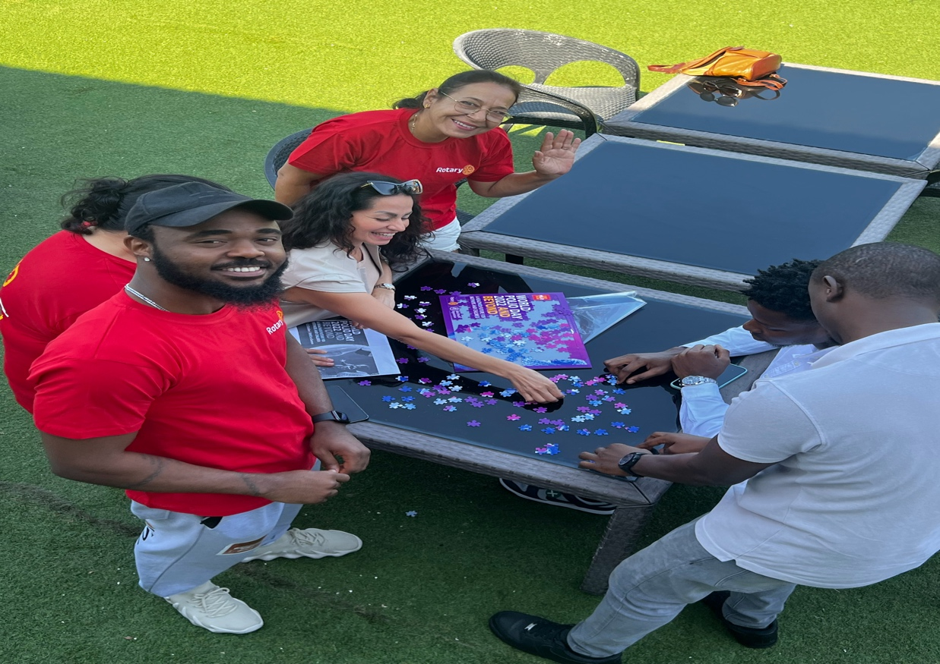
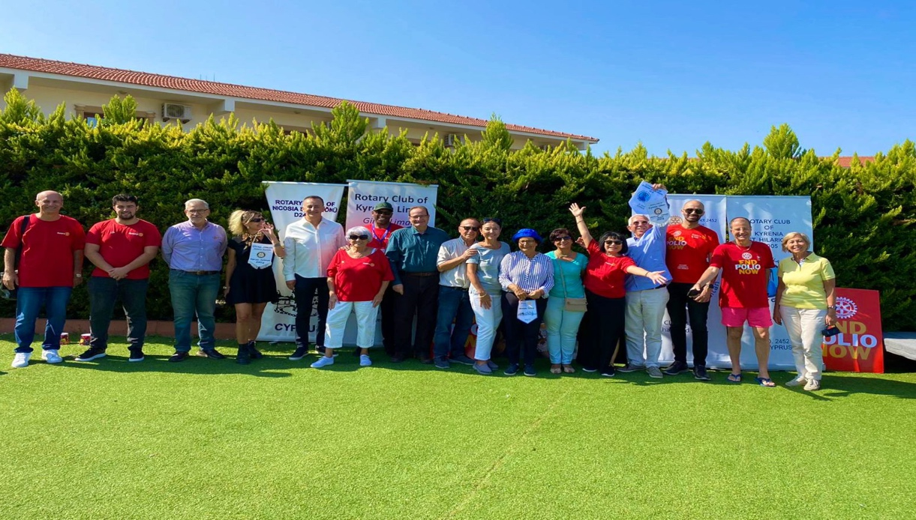

ANNUAL HALLOWEEN PARTY

On 29th October we held our annual Halloween fund raising event. The extremely successful event was a joint event with RC Kyrenia Cosmopolitan Rotaracts and was held at Bar O Monte. We also used this event to continue raising polio awareness. We raised 3, 615 TL to go towards our work with the educational development of children and young people.
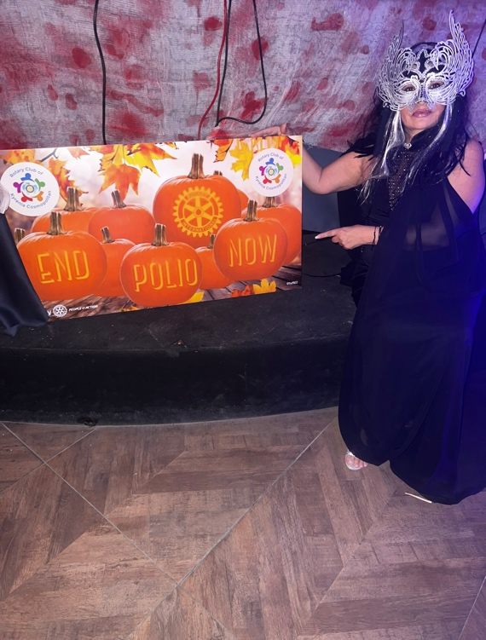
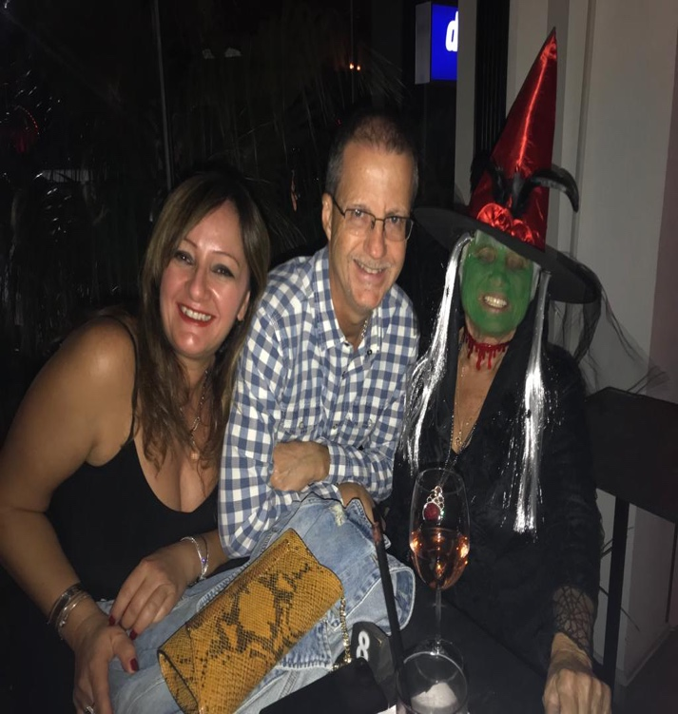
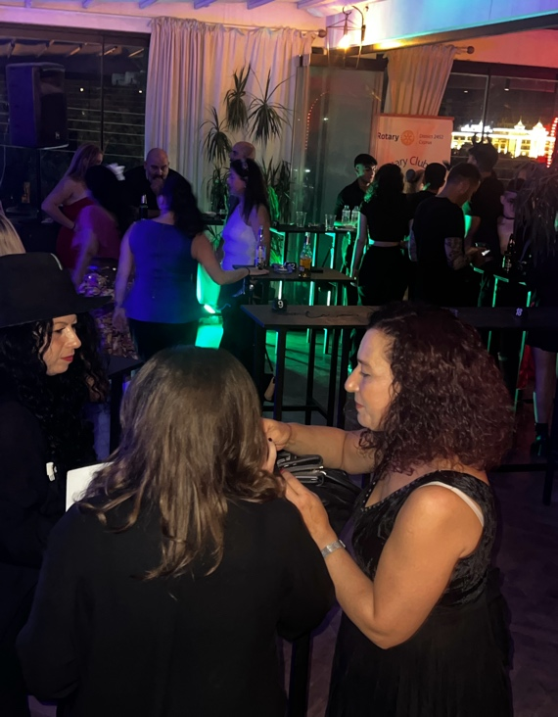
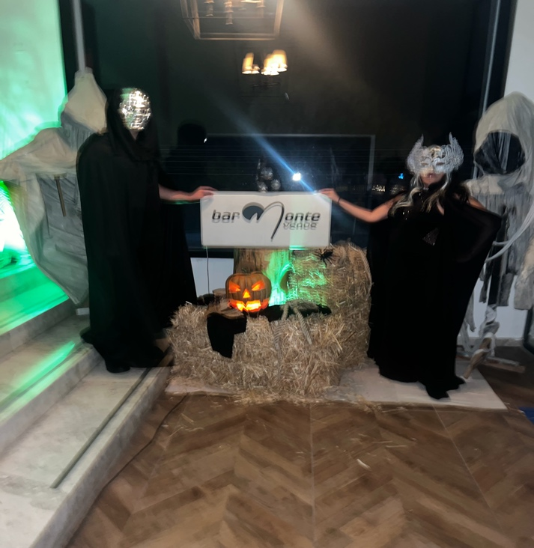

OCTOBER ECONOMIC AND COMMUNITY DEVELOPMENT MONTH

Keeping in line with the Rotary’s Monthly Themes, on 29th of October our Past President Mr Ben Benoit was invited as a guest speaker at the ‘ Cyprus Evolve, A Personal Development, Leadership and Career Success Conference’, organised by 360 Leadership Network. The Aim of the conference was supporting the development of young leaders and entrepreneurs. Following on from his presentation we have four bright and enthusiastic young people who are interested in becoming Rotarians.
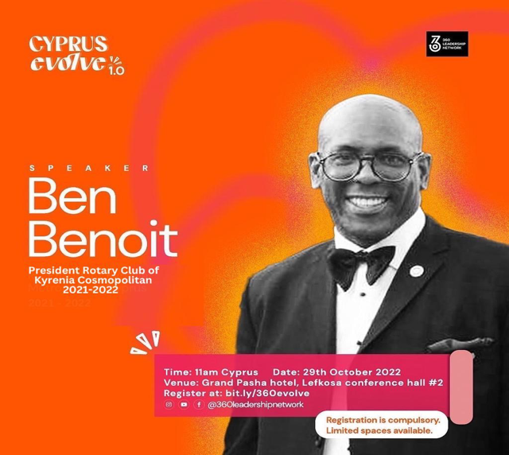
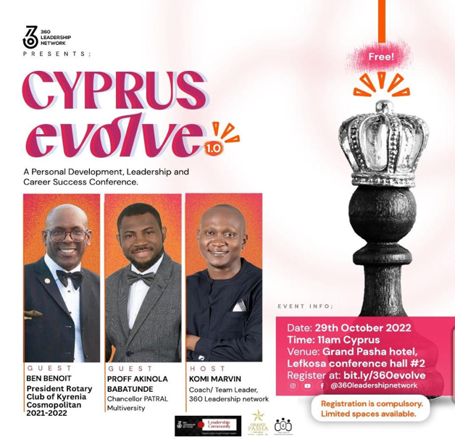

In addition to the above I have also been busy with writing and trying to finalise the Memorandum of Understanding for the sponsorship of the Karsiyaka schoolchildren Project, as well as writing to the ministry of education to receive approval for us to deliver our planned work at the Karsiyaka school. Things are still in working progress, so hopefully I will be able to provide more information in my feedback in November.

Octobers ending quote

“ Let your smile change the world
But don’t let the world change your smile”

PRESIDENTS UPDATE NOVEMBER 2022

ZONE 21 INSTITUTE

The highlight for the month of November has to be the zone 21 Institute held in Limassol from 9th to 13th of November, with RI President Jennifer Jones attending the Institute. Although several members of our club attended, unfortunately despite booking for the event due to health reasons and family bereavement, I missed out on this amazing opportunity. I was informed that it was a very well organised and very informative event, our respect to PDG Christina Covotsou Patroclou and her amazing team for making us proud.

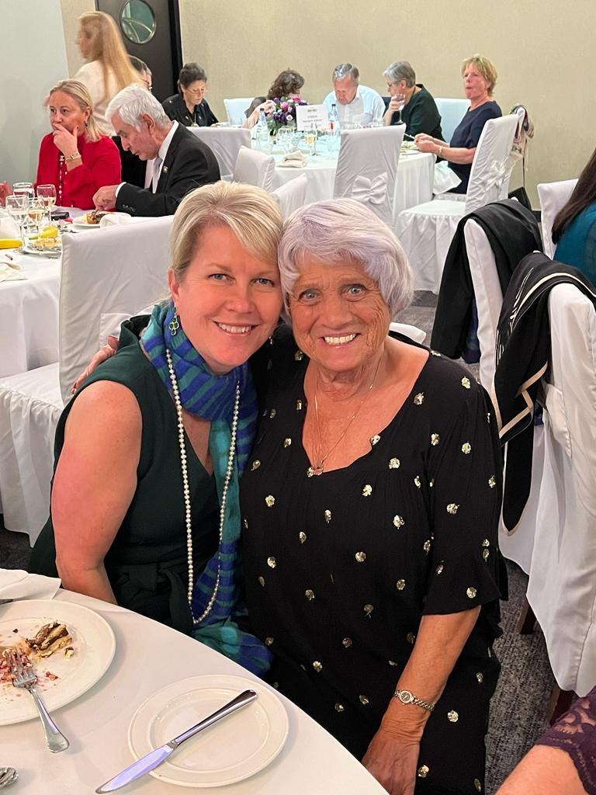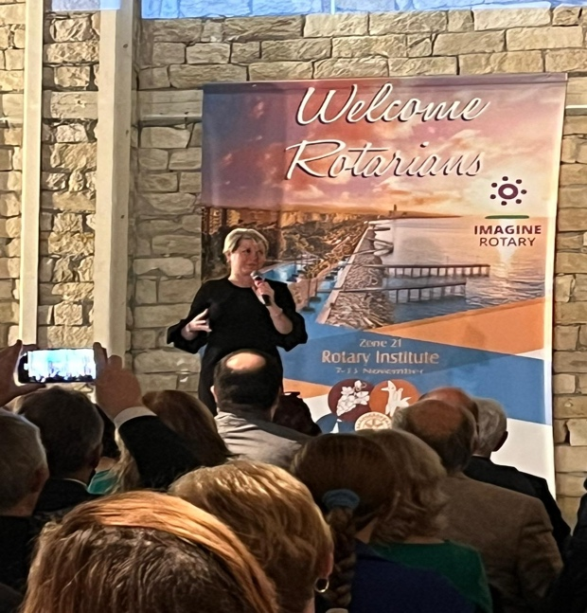

JENIFER JONES VISITS NORTH CYPRUS

The best news of all was being informed that RI President Jenifer Jones, despite her very busy schedule, wished to also visit North Cyprus and have the opportunity to meet up with Rotarians in North Cyprus who were unable to attend the Institute in Limassol.

The four Rotary Clubs in North Cyprus hosted a lunch meeting at the historical venue ‘Buyuk Han’ in Lefkosa. RI President Jennifer Jones crossed the Green line accompanied by Christina Covotsou-Patroclou and Katereina Kotsali-Papadimitriou, Rotary International Director 2020-2022.

It was an extremely memorable meeting, President Jenifer Jones won the hearts of all who attended with her warm, grounded and charismatic personality.

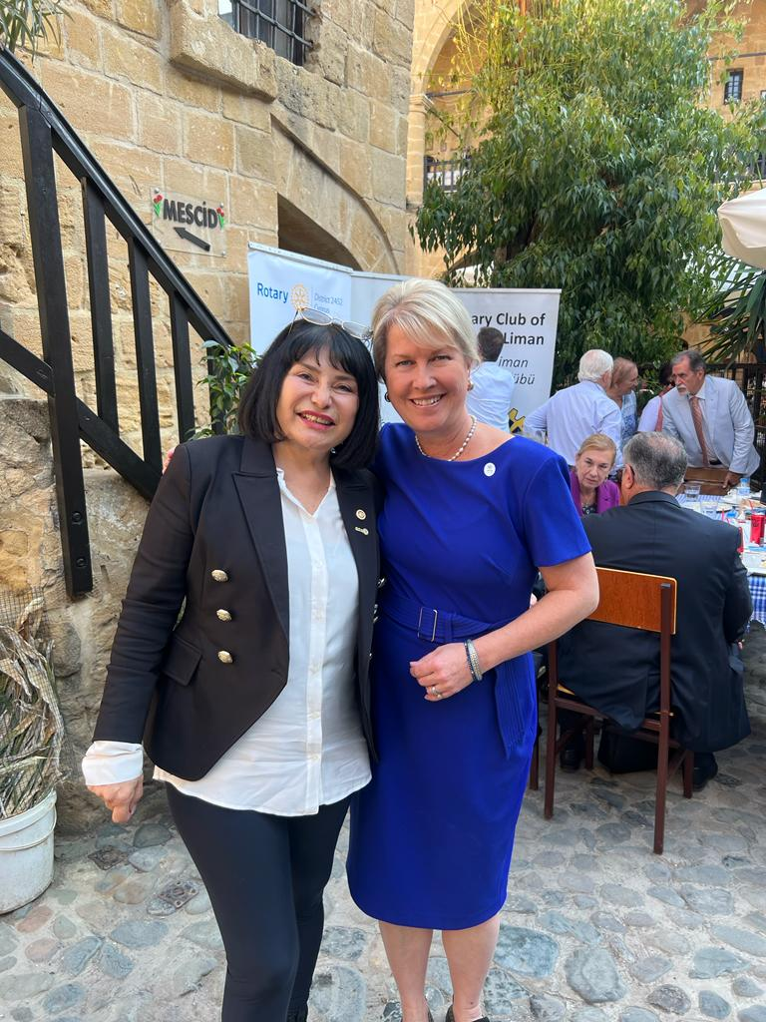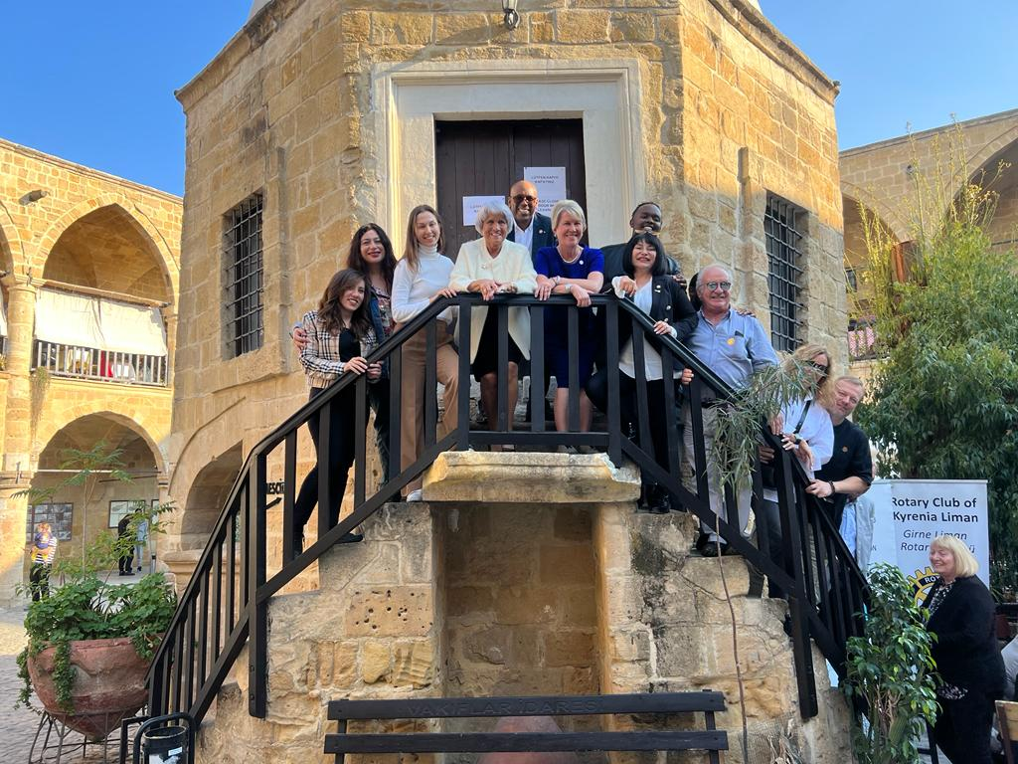

KARSIYAKA SCHOOLCHILDREN PROJECT

Following several months of planning, clarifying vision for project, getting approval from Ministry of Education and agreeing the terms, RC Kyrenia Cosmopolitan and Friends of Karsiyaka Schoolchildren signed The Memorandum of Understanding on 25th November at Jessics restaurant. RCKC received 60,000TL from ‘Jessics, Friends of Karsiyaka Schoolchildren’ sponsoring our club to plan, coordinate and monitor projects which support and raise the aspirations of Karsiyaka schoolchildren. This project will be providing two sessions of additional English lessons to year 4 students and two sessions of additional English lessons to year 5 students each week during the afterschool period. In addition, we will be purchasing a robotic Lego kit to enable children to build robotic Legos and support in increasing their computer skills in a fun way. We will be developing a pollination garden as well as utilising the schools green house by planting vegetables which will be cared for and maintained by the students. The vegetables will be distributed to families in need living in the locality, the children will be part of the decision making process, this process will foster empowerment as well as develop an understanding of humanitarian actions. The school will also identify around ten children with leadership skills who will be trained up as young Interacts.
The first of the Afterschool English lessons for year 4’s will commence on Tuesday 6th and for year 5’s Thursday 8th December 2022.

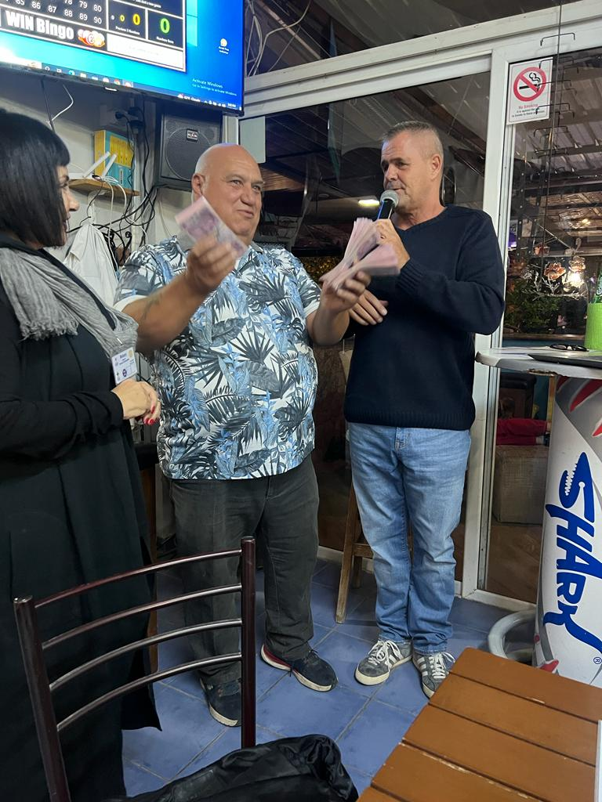

BOARD AND MEMBERS MEETING

We held our board and members combined meeting on 26th November at The Heaven Restaurant. It was good for members to get together following a long gap to our scheduled meetings due to the ‘End Polio Now’ event in late October and the ‘Zone 21 Institute’ early November falling on the same dates of our meetings.

It was an additional bonus to have 3 guests join our meeting with the aim of finding out about our club and considering becoming fellow Rotarians.

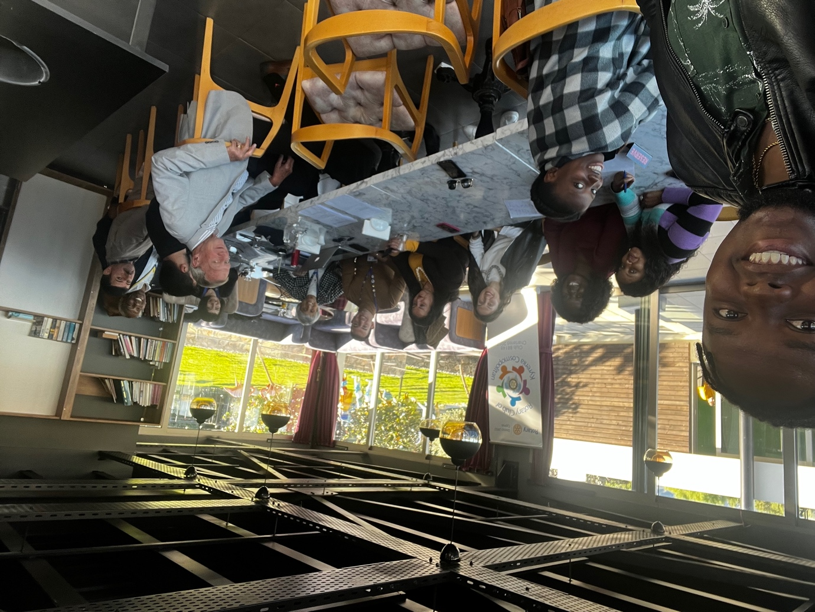

my ending quote for this month is

“Be the reason someone smiles today”

Thank You
Ayten Benoit
President 2022-23
RC Kyrenia Cosmopolitan

